’Warranty/Claim/Returns’ problem with ’Access Denied’ or it is not possible to print.
Note! Close all open Chrome sessions. The workaround do not work with an open Chrome session.
Start Chrome
Write the: Portal.oro.com in address field and press enter
Logg in with our user-id and password
click on ’Customer support’
Select ’Warranty/Claim/Returns’
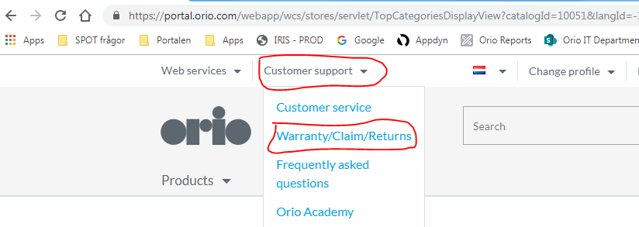
This is the WRC page (’Warranty/Claim/Returns’) in a new window. If you have a screen saying ‘Access Denied’ or it looks normal, continue with the next step below.

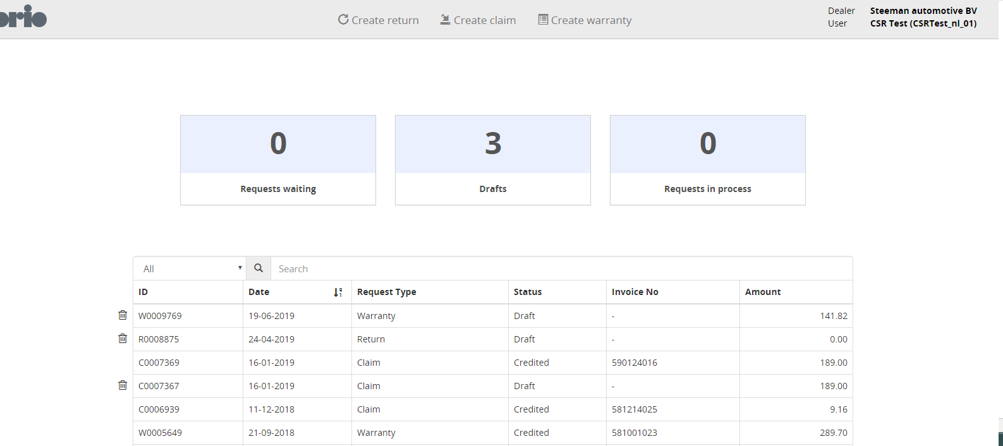

Press ’F12’
Locate and click ’Application’ pos 1 (it is possible that you need to increase the window size before you can see ‘Application’. Hover over boundary between the windows, when a double arrow occur, press left muse key and drag the window to the left)
Click ’Clear storage’ pos 2
Click ’Clear site data’ pos 3
Click ’X’ pos 4

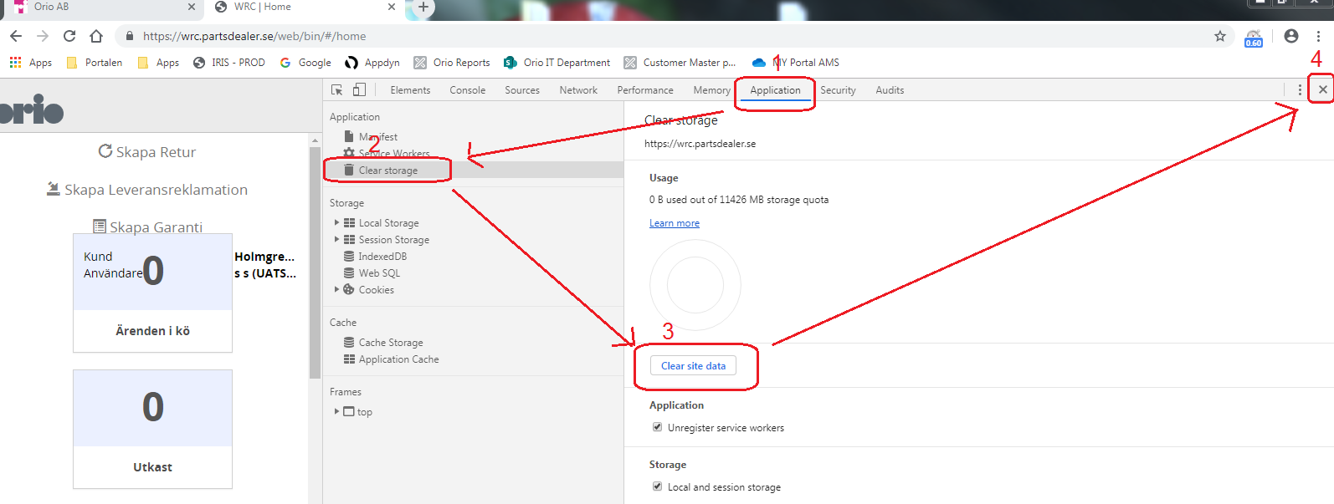
Close WRC window and press ‘F5’ in portal window
Now it is done and WRC is now working, if the problems occur again do the work around again.

