Warranty


Warranty cases are created in the HPL Portal.
Log in with username and password:
Under the customer service tab you will find WRC 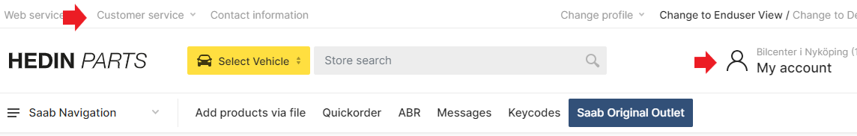
Click on wrc icon
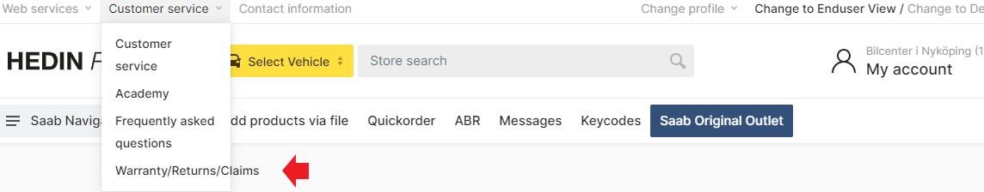

Under WRC you will find all your created cases.
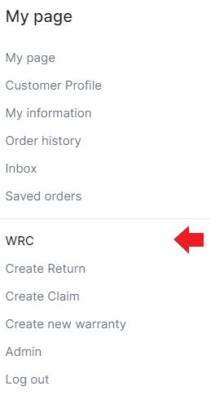

You can search for a case that has been created in the various fields
Case = case number.
Article = The article number of the spare part.
Type = Return, Delivery complaint and Warranty
Date= Search within a date range in created cases.
Status= Search through different statuses on the case Ex sent, Credited, Rejected etcetera.

Create a Warranty :

1. Click create a Warranty case.
2. Fill in the information required to create the case
3. Under ? icons in the case, there is additional information about what is being searched for in order to create the case.
4. Article = Enter the article number of the part for which a warranty claim is desired. Press Add. 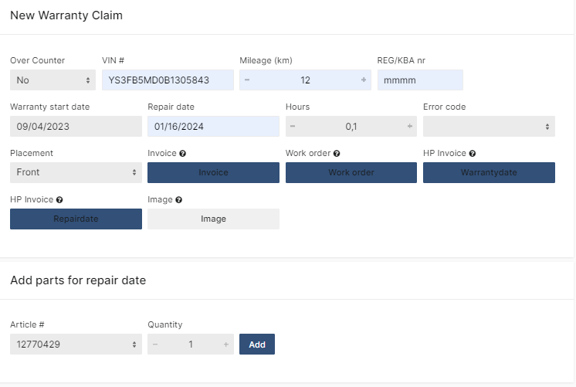

5. Now an article is registered and you can choose to register an additional article number to the case if there is a warranty claim also on that part as shown.
6. Comment on the case: enter detailed information why the part needs to be replaced under warranty
If there are error codes that are related to the warranty part, this must also be noted.
7. Upload all lines = Case registered
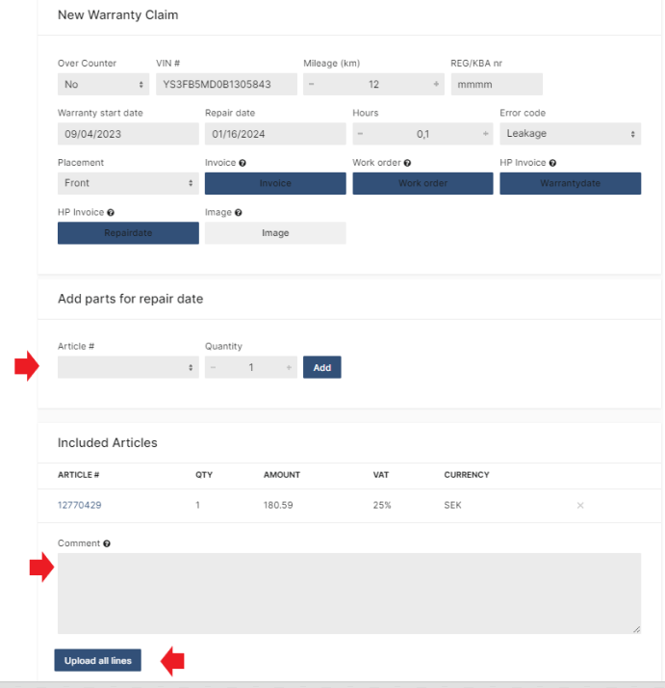
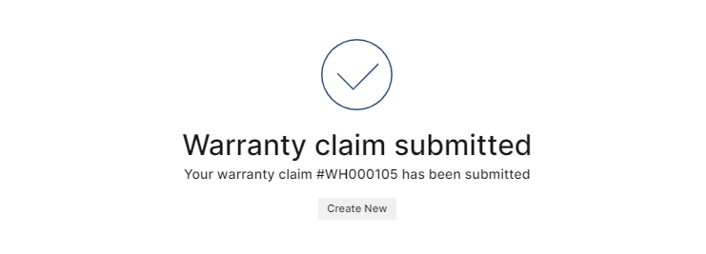

All registered cases end up in the WRC tab
Newly registered cases ends up there as submitted.
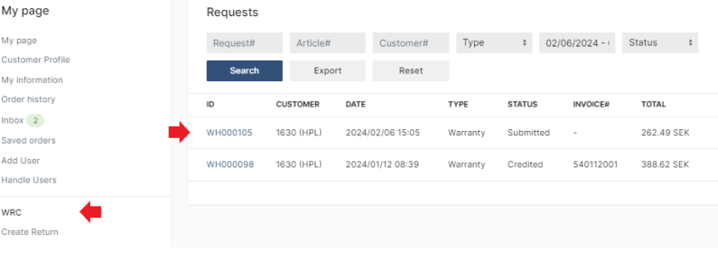Any communication with HPL will take place within the case.
When HPL has looked at the case and commented, it can be seen as shown in the picture with the envelope symbol on the right hand side. A email notification will also be sent out to the user.

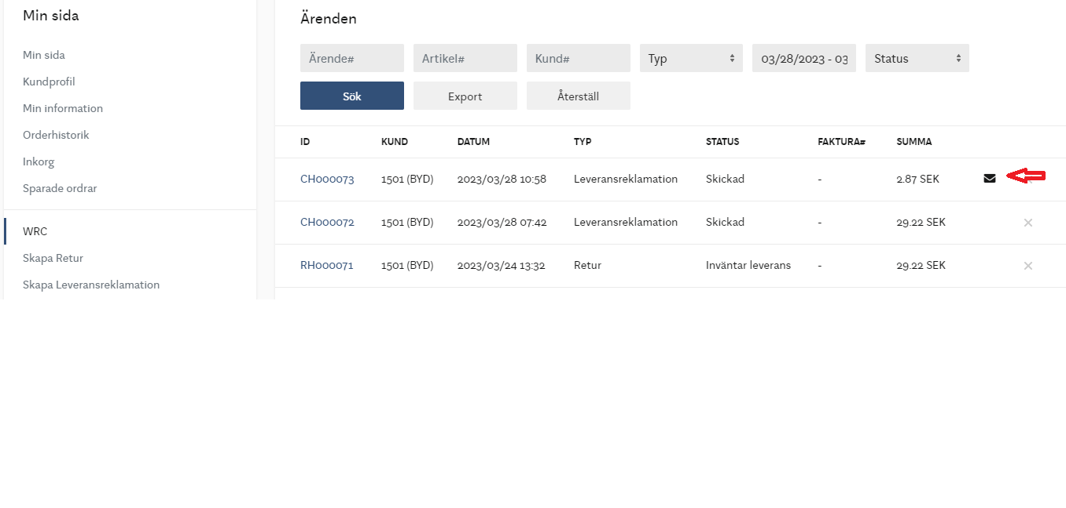

The claim will then show as having changed to update requested = HPL warranty team needs supplementary information to be able to proceed with its assessment of the matter.
Open the case to continue. Example of conversation flow is in the below screenshot.
In this case, a picture of the damaged part is requested. Attach it under documents. Comment and post comment.
You must then Complete with the information requested by HPL.
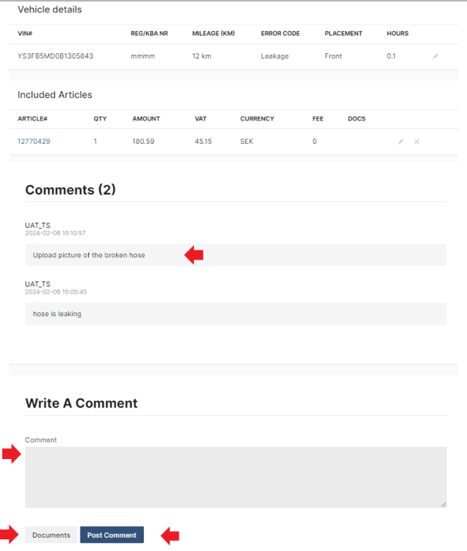

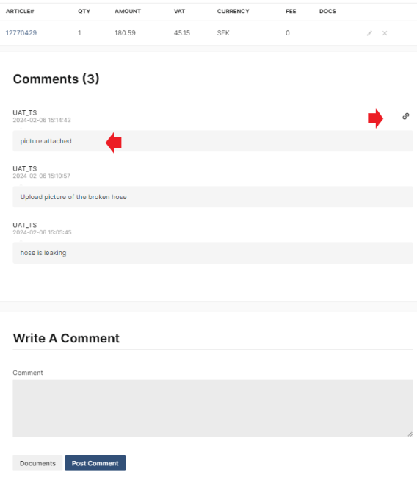

In cases where HPL wants parts to be sent back, you can print out the relevant documents from the case. It must accompany the goods back.
The status is then awaiting home shipment and HPL continues to handle the case when the part arrives at the warehouse.
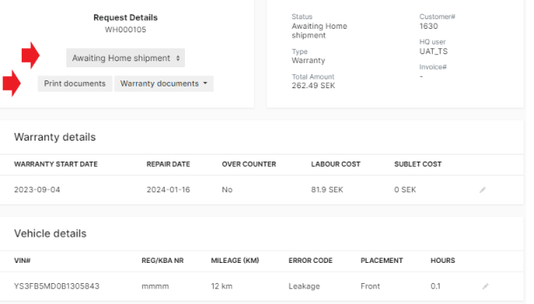

Explanation of different statuses in the handling flow of your Warranty cases:

Submitted = Case submitted and to be handled by HPL.
Approved = Case approved, credit invoice is created.
Credited = Credited, at the same time the credit invoice number from HPL is visible.
Awaiting home shipment = HPL is waiting for the parts to return to the warehouse,
print out documents inside the case and send back if this is requested.
Update requested = HPL has commented on the matter
Rejected = Rejection of Delivery complaint (see comments in the specific case)
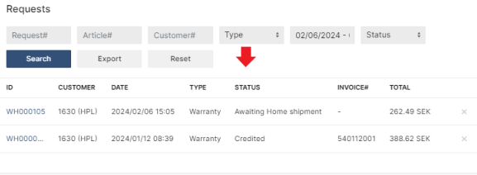

Vid ytterligare frågor kontakta:
HPL Customer support Sweden: customer.support.nordic@hedinparts.com

