Start page
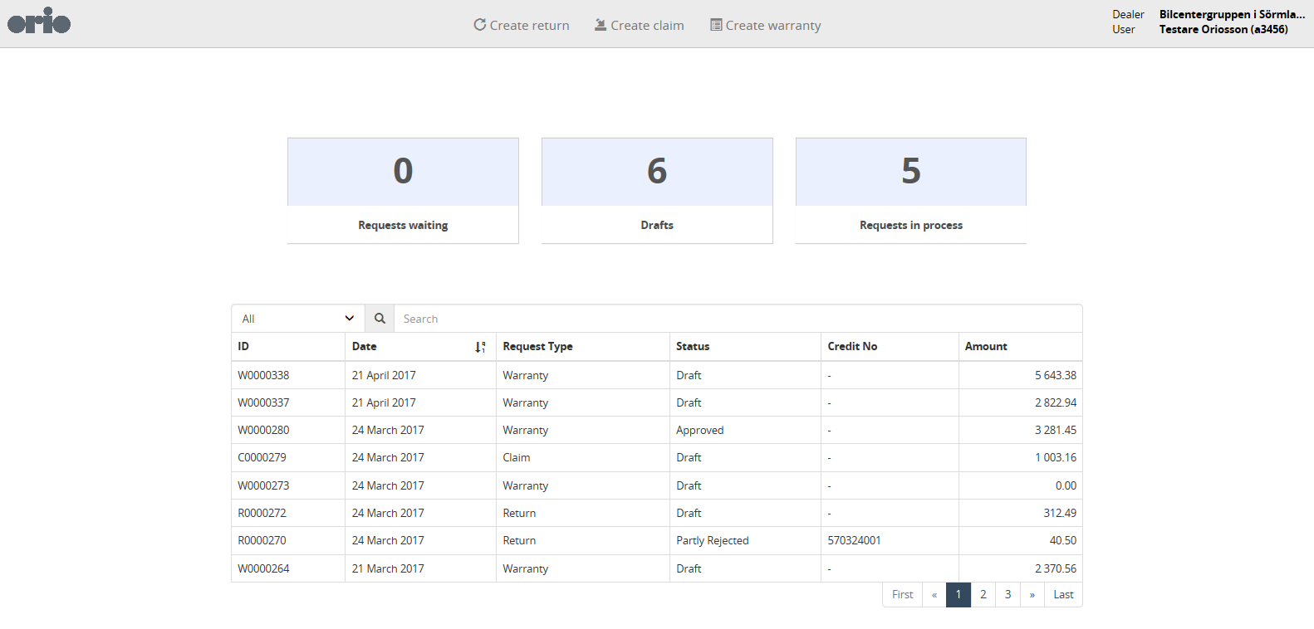
1
2
8
7
6
3
5
4
Recommended web browser is Chrome. For Internet Explorer, some settings in the combability view could be necessary for correct functionality and version 10 or higher is supported
Start page
1. Menu: Here you can choose to create new cases like Returns, Claims or Warranty.
2. User: Shows your customer information and what user is logged in.
3. Requests waiting: Shows the number of open cases waiting actions from You. Click on the number to show the cases in the case list below.
4. Drafts: Shows number of cases started but not submitted Click on the number to show the cases in the case list below.
5. Requests in process: Shows the number cases you have sent and are waiting for actions by Orio. Click on the number to show the cases in the case list below.
6. Search function: Possibility to search for different cases by free text or by field.
7. Case list: Shows all cases chosen or searched. If no search criteria or type chosen all cases is shown. The unique ID given to each case represents the type of case it is. W for for Warranty, R for Return and C for Claim
8. Orio logo: By pressing the Orio logo you will return to the start page.

Create Return
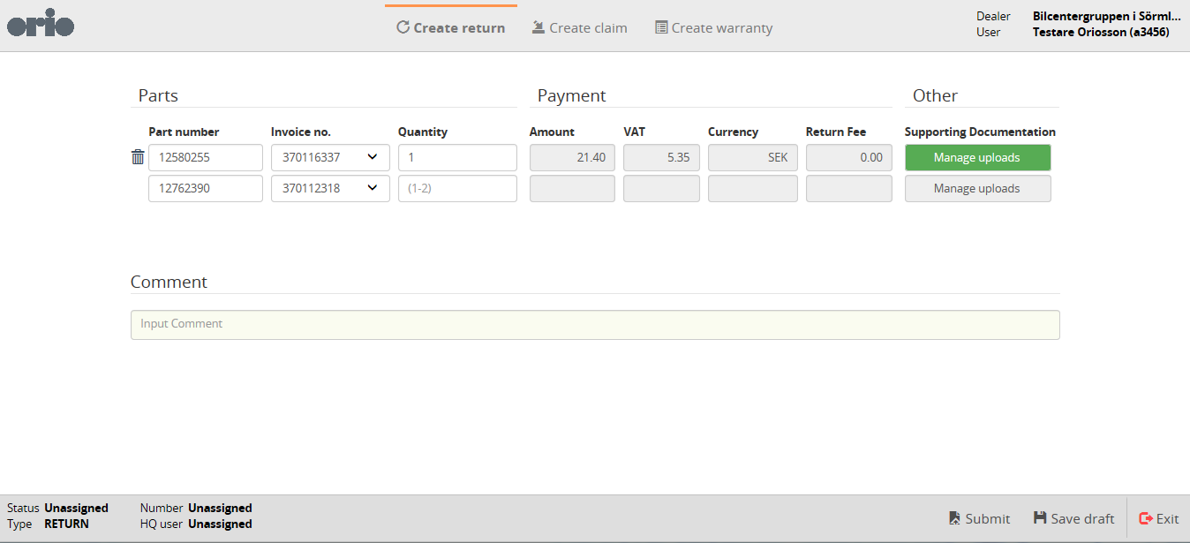
Enter and chose the part number you want to return.
Chose in the dropdown the corresponding invoice.
In Quantity is shown the number of parts that can be returned on the invoice and the small pack quantity (example: 4-2 means that 4 parts can be returned but need to be sent 2 by 2).
When the quantity to return is set the amounts will be populated automatically according to the corresponding invoice and return fee, if applicable.
Documents can be uploaded and sent with the case by pressing the Manage uploads button .
Any comments to the case can be stated in the comment box.
When all data is recorded press submit to register the case at Orio then press to print the delivery note that shall be sent with the goods.

Create Claim
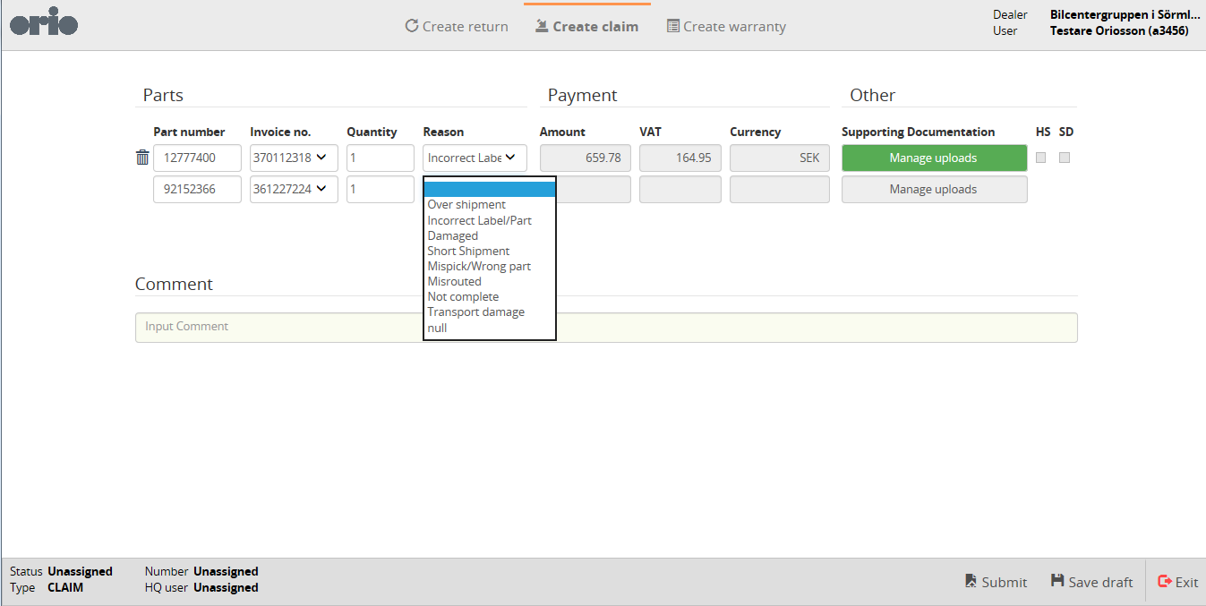
Type in and chose the part number to be claimed
Chose in the dropdown the corresponding invoice
In Quantity is shown the number of parts that can be returned on the invoice and the small pack quantity (example: 4-2 means that 4 parts can be returned. For claims the small pack quantity is not applicable).
Chose the reason for the claim from the dropdown.
When reason for the claim have been stated the amounts will be populated automatically according to the invoice.
Evidence by documents like pictures or documents is uploaded by pressing the Manage upload button . Please note that Pictures are mandatory in case of damaged goods.
Any comments to the case can be stated in the comment box.
You can at any time safe the document as a draft by pressing the . The case is then placed in the category Drafts in the start page.
You can at any time leave the case by pressing . If there are unsaved changes you will be given the alternative to save the document before exiting else you will be re-directed to the start page.
By pressing the case is sent to Orio for processing. The case is then placed in the category Requests in process on the start page.
If Orio wants to receive more supporting documentation the checkbox SD (Supporting Documentation) will be checked with a comment on what documentation is needed. The case will then be moved to the category Requests waiting on the start page. When the case is updated with documentation and re-submitted to Orio the case will be moved to the category Requests in process at the start page.
If Orio wants to receive back the part the checkbox HS (Home shipment) will be checked with a comment to send the goods. The case will then be moved to the category Requests waiting on the start page. When the parts are sent and the case been re-submitted to Orio the case will be moved to the category Requests in process at the start page with the status Awaiting Home Shipment.
is then used to print the delivery note that shall be sent with the goods (data is only visible after Orio have requested the goods back)

Create Warranty
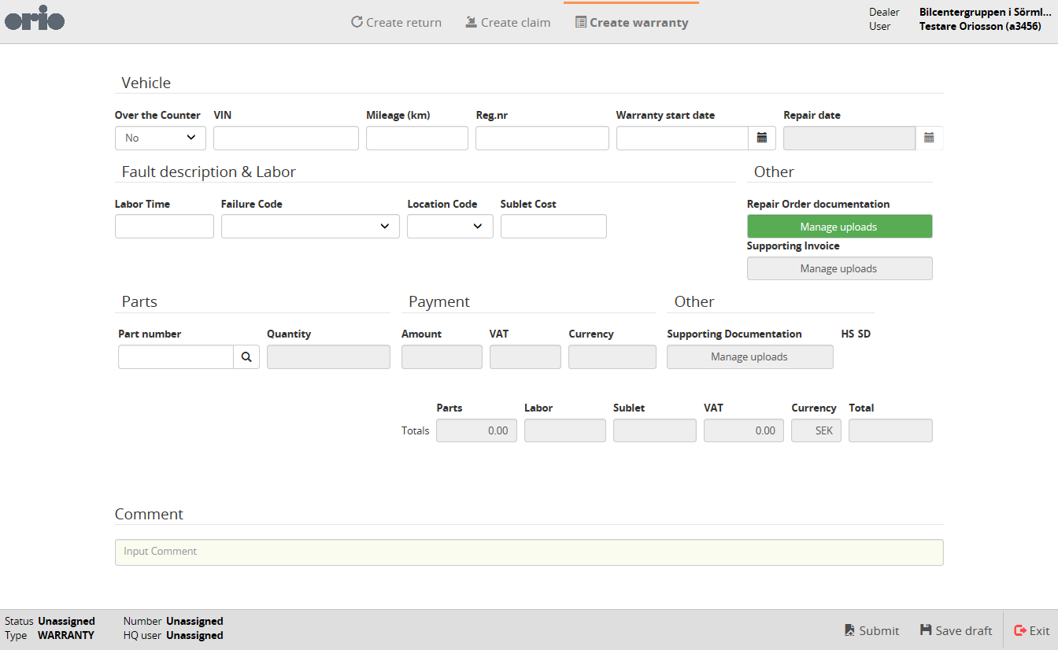

If the warranty is applied to a part sold Over the counter, VIN and Mileage is not applicible. Neither labour time and sublet cost.
If the warranty is applied to a part not.sold over the counter VIN and Mileage is mandatory.
The registration number of the car is always to be filled.
Warranty start date is when the part was mounted on the car or sold over the counter.
Repair date is when the claimed part has been replaced on the car or over the counter.
Labor time used for the repair is stated in hours. Part of hours are separated by . e.g. 0.5. Not applicable if sold over the counter.
Failure code and location code is chosen from the dropdowns
If the failure is repaired by the workshop it is mandatory to upload the Repair order documentation by pressing on Repair order documentation.
If the part is sold over the counter it is mandatory to upload the Customer invoice by pressing on Customer invoice
Sublet Costs are any additional costs occurred repairing the failure. These cost needs to be supported by documentation uploaded by pressing on Customer invoice
Parts that are claimed within the warranty are filled in with Orio’s part number and chosen by pressing 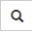. When the quantity is filled, the amounts are automatically populated based on current price list and contract. These parts need to be supported with the invoice uploaded by pressing on Supporting documentation
Any comments to the case can be stated in the comment box.
You can at any time safe the document as a draft by pressing the . The case is then placed in the category Drafts in the start page.
You can at any time leave the case by pressing . If there are unsaved changes you will be given the alternative to save the document before exiting else you will be re-directed to the start page.
By pressing the case is sent to Orio for processing. The case is then placed in the category Requests in process on the start page.
If Orio wants to receive more supporting documentation the checkbox SD (Supporting Documentation) will be checked with a comment on what documentation is needed. The case will then be moved to the category Requests waiting on the start page. When the case is updated with documentation and re-submitted to Orio the case will be moved to the category Requests in process at the start page.
If Orio wants to receive back the part the checkbox HS (Home shipment) will be checked with a comment to send the goods. The case will then be moved to the category Requests waiting on the start page. When the parts are sent and the case been re-submitted to Orio the case will be moved to the category Requests in process at the start page with the status Awaiting Home Shipment.
is then used to print the delivery note that shall be sent with the goods (data is only visible after Orio have requested the goods back)

