
Return handling

Returns are created in the HPL Portal.

Log in with username and password:
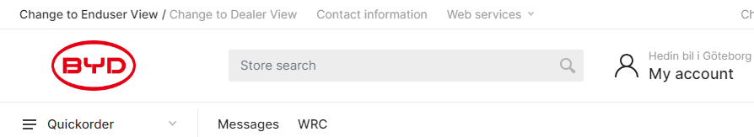

Click on the WRC icon:

Under WRC you will find all your created cases.
You can search for a case that has been created in the various fields.
Case = case number.
Article = The article number of the spare part.
Type = Delivery complaint, Returns.
Date= Search within a date range in created delivery complaints and Returns.
Status= Search through different statuses on the case Ex sent, Credited, Rejected etcetera.

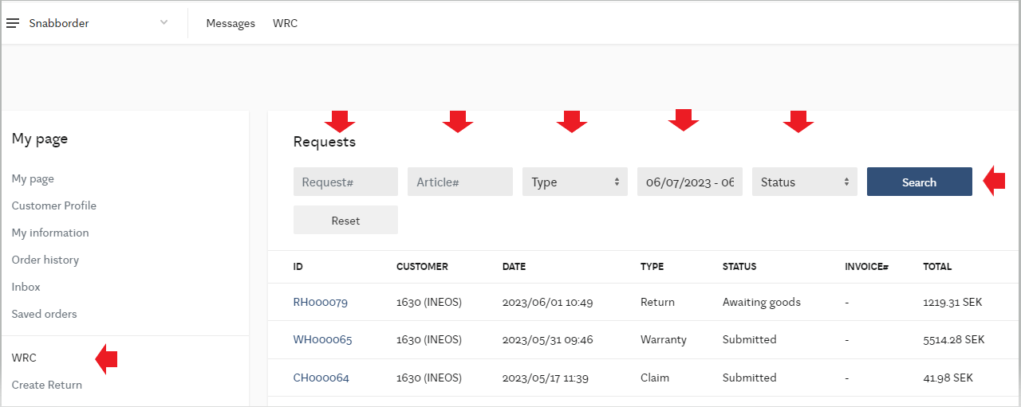

Create a new Return:
1 Press create return.
2. Article: enter the article number to be returned, you can enter it manually or find in
scroll list.
3. Invoice: select invoice. if you ordered the same item several times within the TBD day period be
careful by taking the correct invoice.
4. Quantity: select quantity to be returned.
5. Documents: Documents can be uploaded in the case if necessary.
6. Create: The case is created.

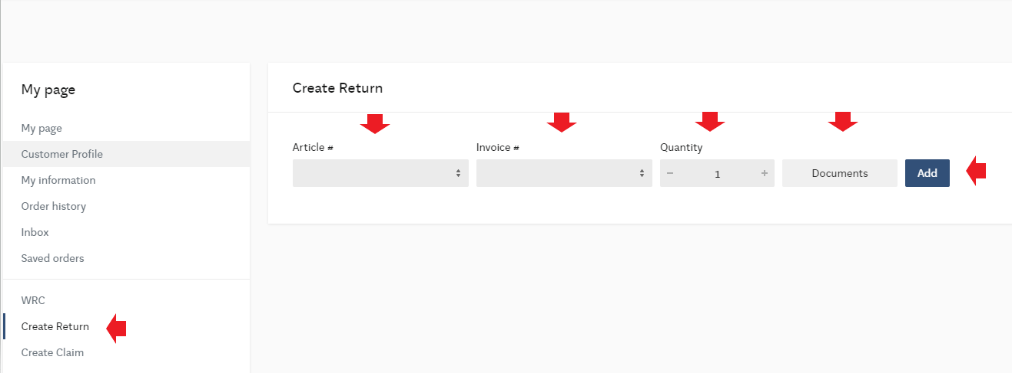

Once an article is registered, you can choose to register any additional article numbers to the case by following the procedure above. See image below:

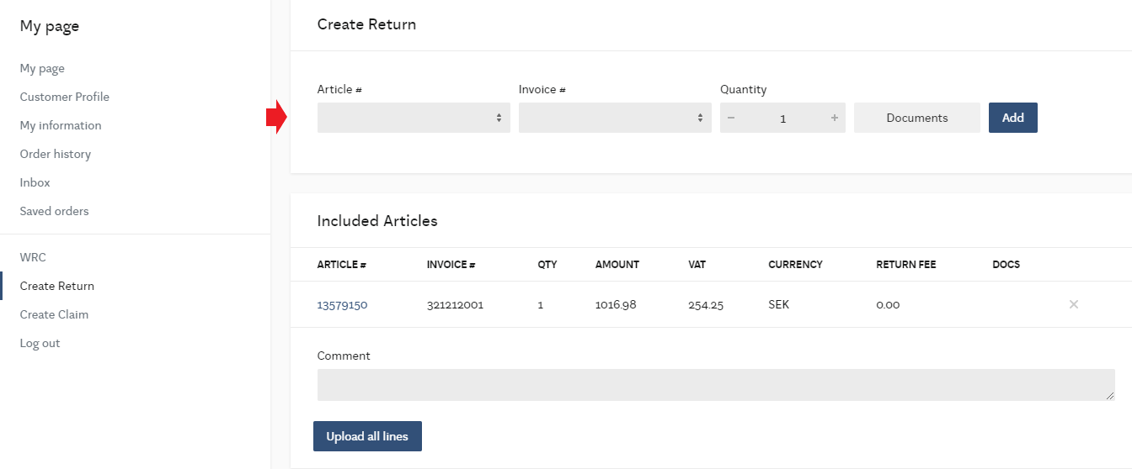
Comment: here you provide information as to the reason the article should be returned to stock.
When all item numbers have been registered to the case you can then register the return. Select Upload all rows = Register case.

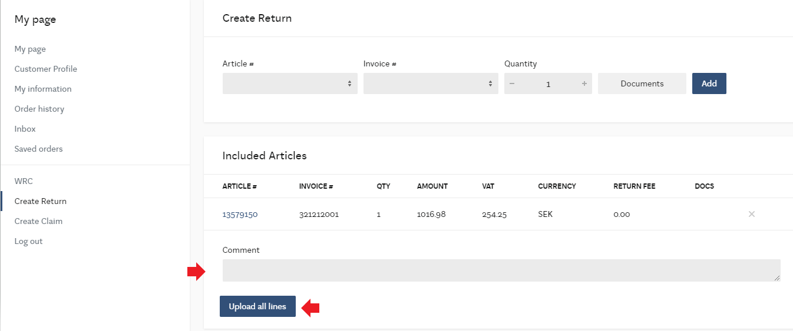

Now your case has been registered and a reference number created.
Ensure you download shipping documents and place them with the shipment.
Status will be awaiting delivery to HPL for inspection and claim handling.
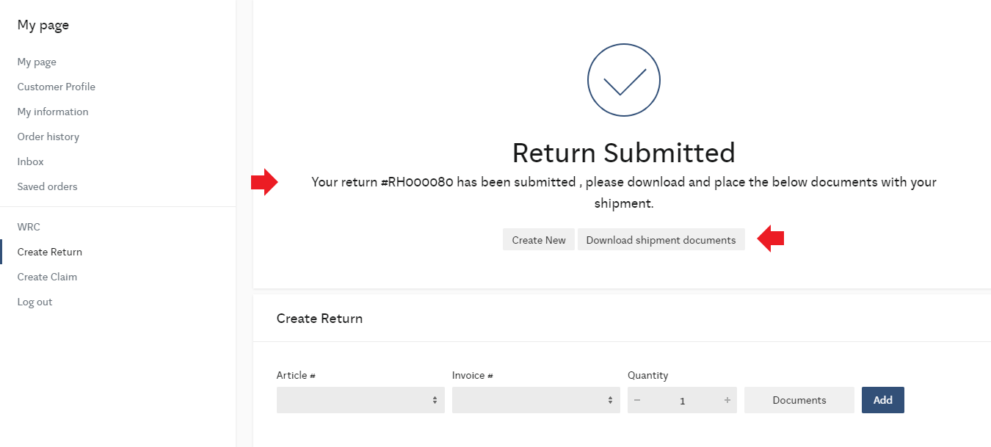

NOTE: Direct delivery parts and function code controlled parts:
We do not automatically accept returns, but the matter must be checked by HPL.
Return is created in the portal and status becomes completion required. HPL will return to the matter further before any return can be approved or rejected. Return documents cannot be printed in this case.

All registered cases end up in the WRC tab.
Newly registered cases will show on the return screen as awaiting delivery back to HPL.

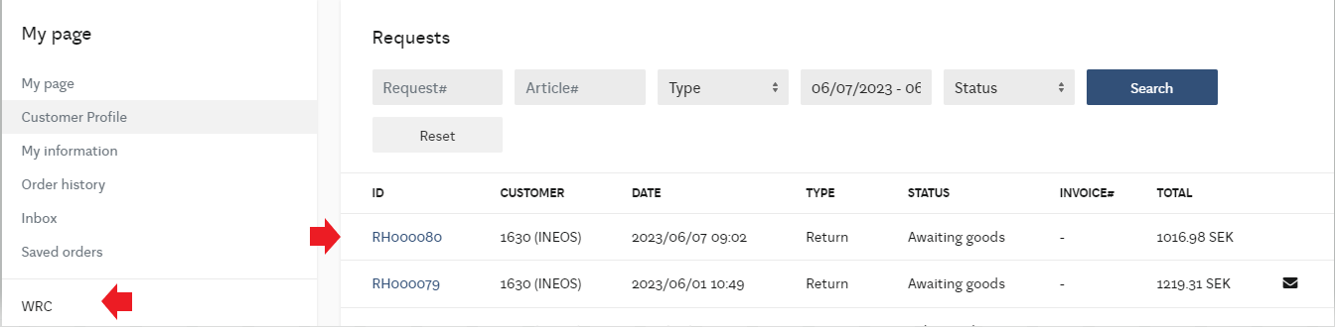

All communication with HPL takes place within the matter.
When HPL has looked at the case and commented, it can be seen as shown in the picture with the envelope symbol on the right hand side. A email notification will also be sent out to the user
Open the case to continue the conversation.
Example:

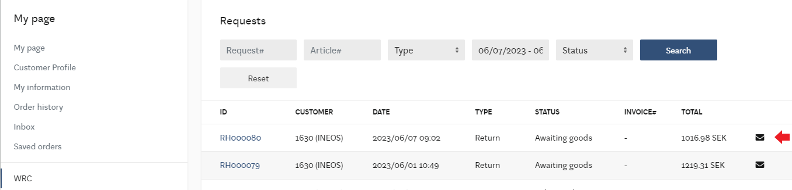

In the comment field, this is where you add any information about the request.
Register it by selecting send comment.
Under the document button, supplementary documents and images can be uploaded if needed to support the request.
When you have downloaded a document or image, the document icon turns blue.
To send and upload documents/images – Add any information in the comment field after uploading and press send comment. Only one document/image can be sent at the time.
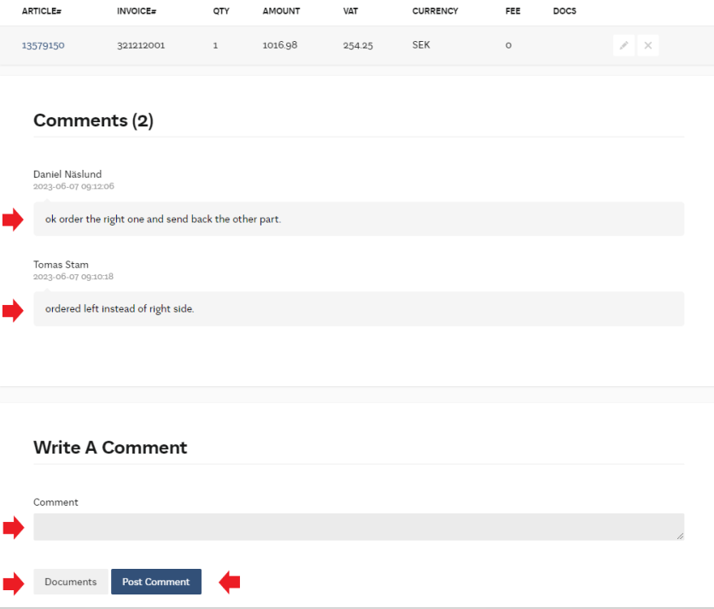

Explanation of different statuses in the returns management flow:
(note some statuses are used for other applications but are visible in the scroll list.)

Awaiting delivery = HPL is waiting for the parts to return to the warehouse,
Returned part approved = Case approved, credit invoice created.
Credited= Credited, credit invoice sent
Update requested = HPL has commented on the matter
Rejected = Refusal of the return (see comments in the specific case)

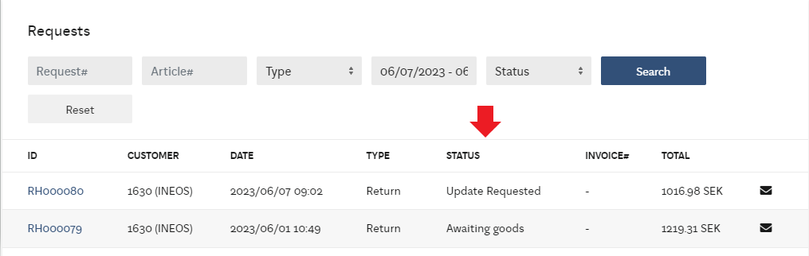

Return Policy:

The customer has a TBD-day right of return. For the return to be accepted, the product must be returned complete, undamaged, including packaging and manuals, in resalable condition.
The right of return does not cover products that have been assembled or fitted to the car.
The right of return of electronic items is approved under the condition that it has not broken seals or otherwise been affected by programming or added/tested in the car.
The period for the right of return runs from when the product was received by the Customer.
HPL will not accept returns of dangerous goods, batteries, pyrotechnic components, manually manufactured products.
For products that are not in stock at HPL:
Direct delivery orders. (Direct delivery)
Will be assessed on a case-by-case basis.
Should the return be rejected, the part will be disposed of, and the customer will not receive a credit.
The customer can request the rejected part returned, the cost of the shipping along with an administration fee, will be charged.

For further questions contact:
ivecosupport@hedinparts.com

