Delivery claims


Delivery claims are handled in the HPL portal.

Log in with username and password:
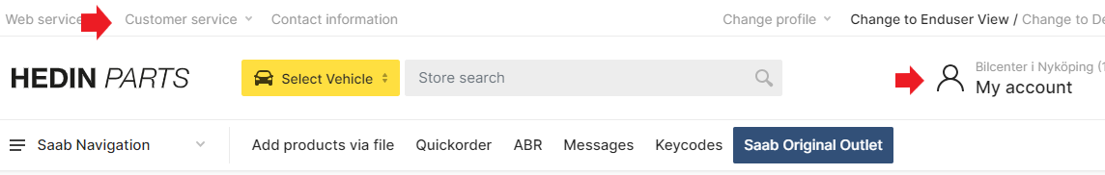
Click on the WRC icon:

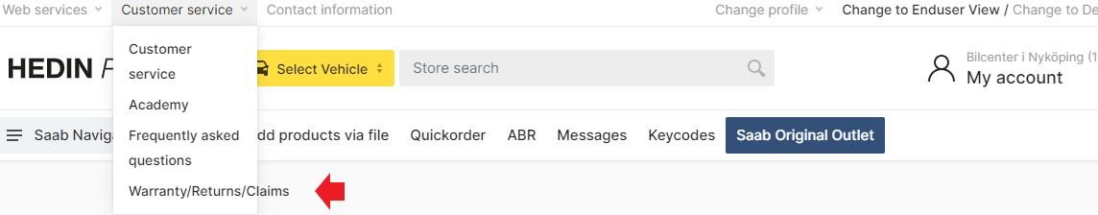

In WRC you find a list with all your issued claims.
You can search for claims in different ways:
Request = Claim number
Article = Part number
Type = Claim (Delivery claim)
Date= Search within a date interval
Status= Search on claim status: submitted, credited, rejected and so on.

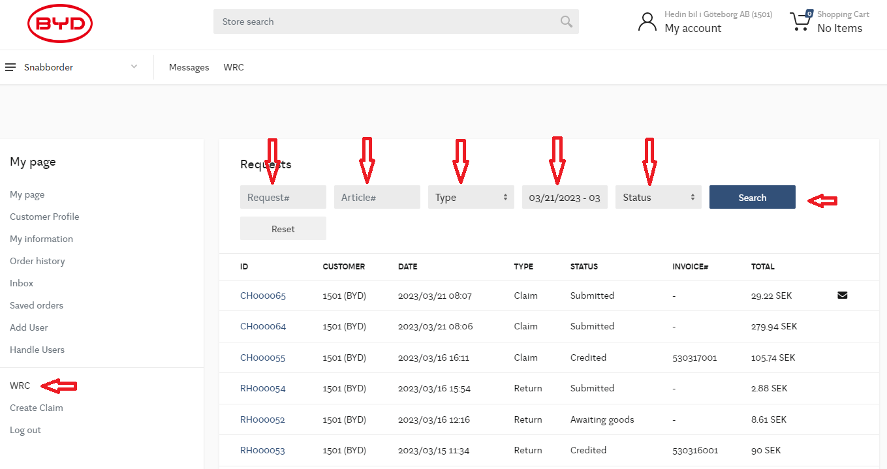

To create a Delivery claim:
1. Click on Create Claim (below WRC on the left)
2. Add the part number. Write it directly or use the scroll list to find it.
3. Select the appropriate invoice, use the scroll list.
4. Select a reason for the claim:
Over shipment = More parts than ordered are delivered. This reason code means that you want to keep the parts and you will be debited. If you do not want to keep the parts, select reason code “Mispack/Wrong” part instead.
Incorrect label/part = Incorrect labelled or wrong part in bag.
Damaged = Damaged or non-working part.
Short shipment = Parts are missing in the delivery. Can be that only 2 of 3 parts with same part
number is delivered or parts with the same Box ID is missing.
Mispack/Wrong part = Wrong part is delivered.
Misrouted = Shipment not delivered or wrong shipment delivered.
5. Quantity = Select quantity.
6. Documents = Here you upload documents and pictures if needed. For damaged part shall a picture
of the box and part always be uploaded.
7. Add = Click Add to add the part to the claim.

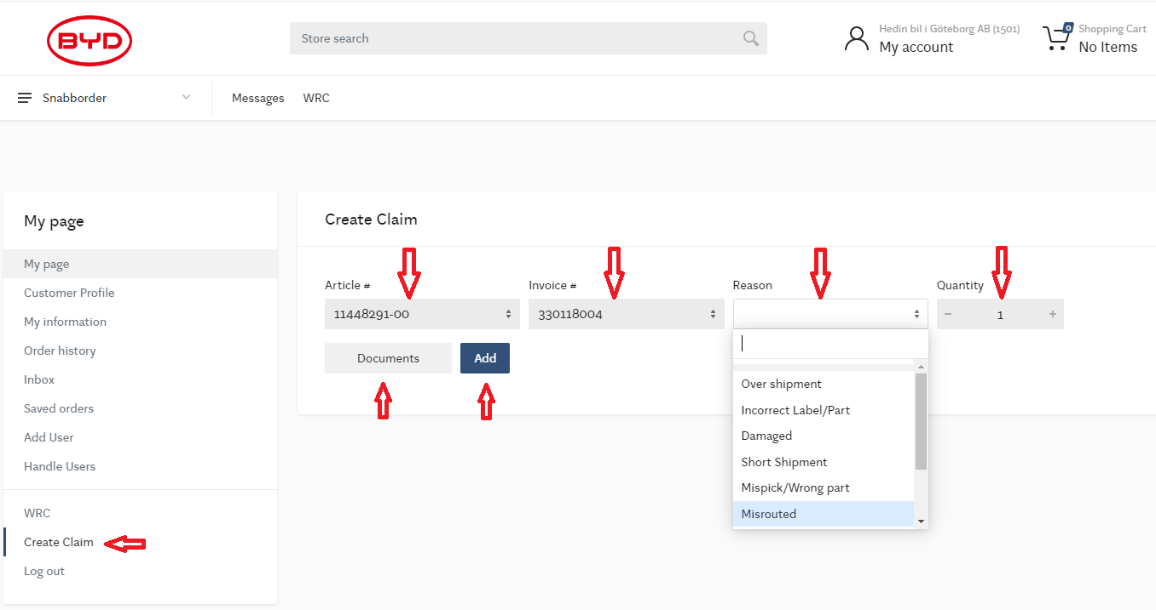

Now is the part added to the claim and can be seen in the list for Included Articles.
If more parts shall be added, just repeat the previous procedure.

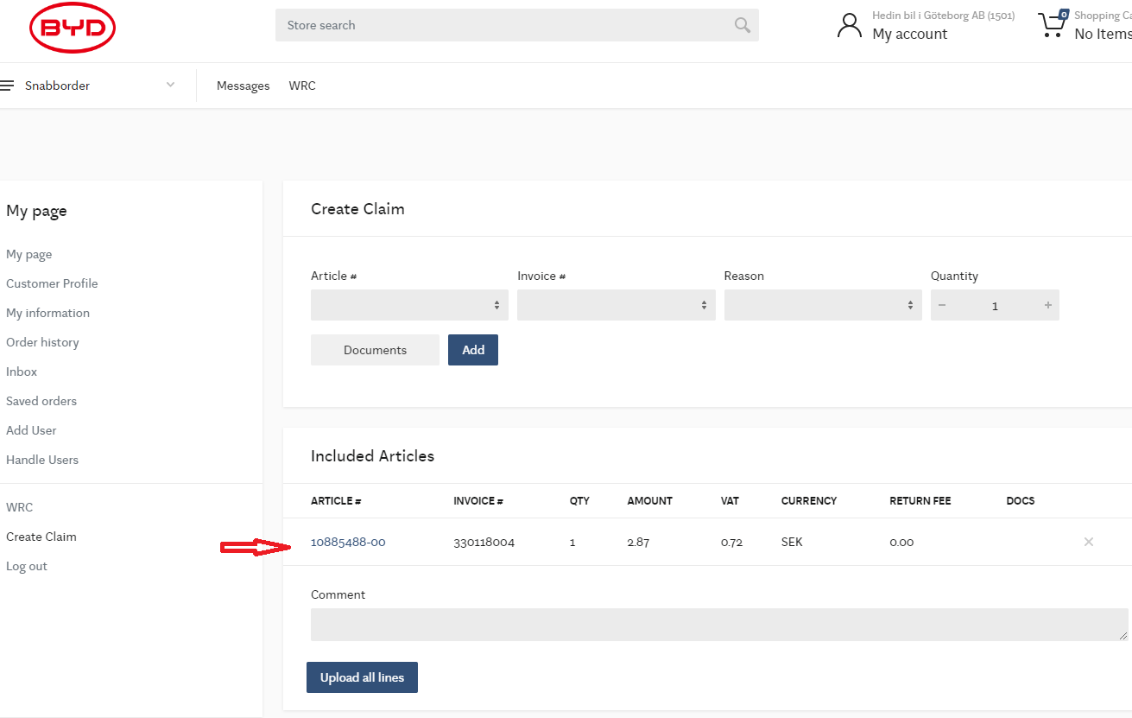

Comment: Here you add information that is required for the claim

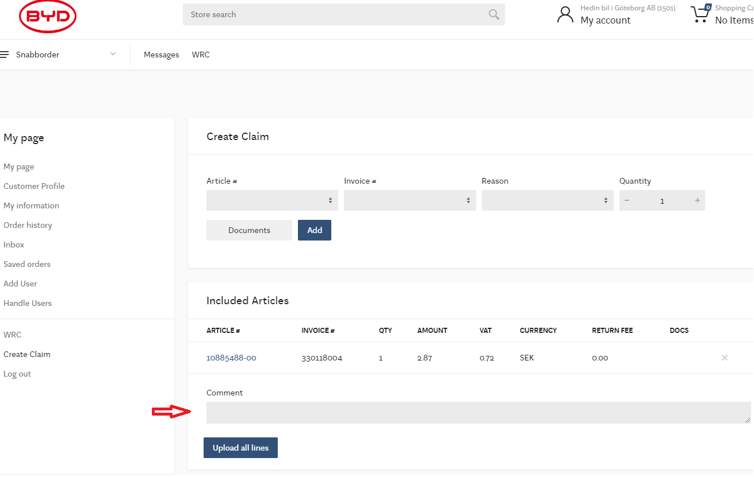
When all parts are added to the case, click “Upload all lines”. The claim will be registered with a claim number.

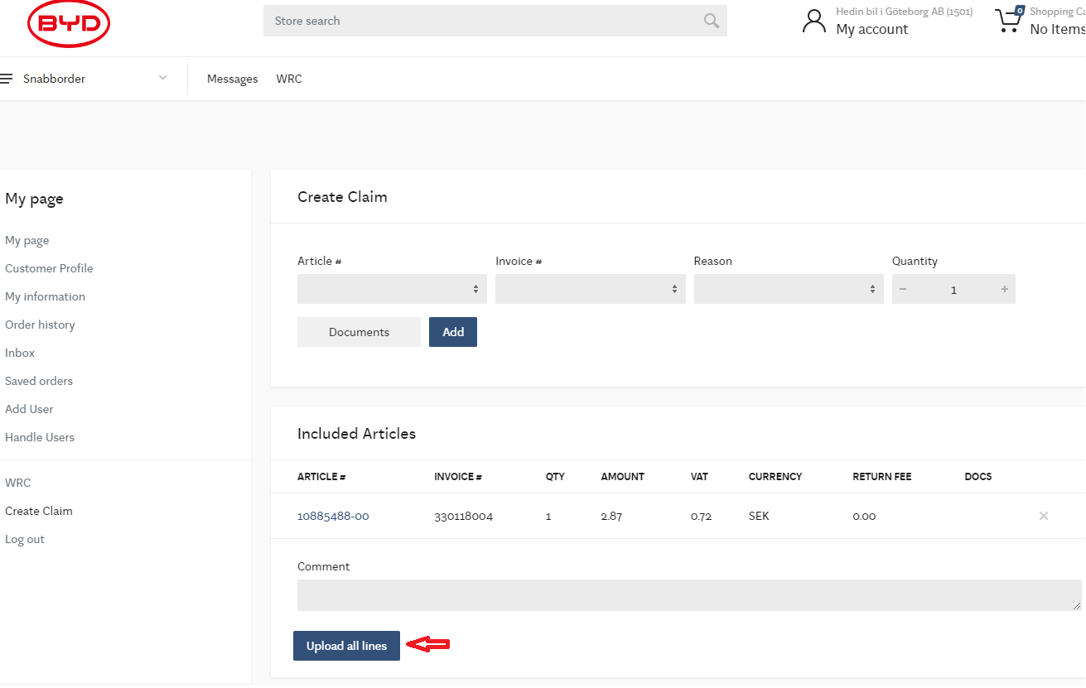

Now is the claim registered and a claim number has been created. The status is ”Submitted” and sent to HPL.

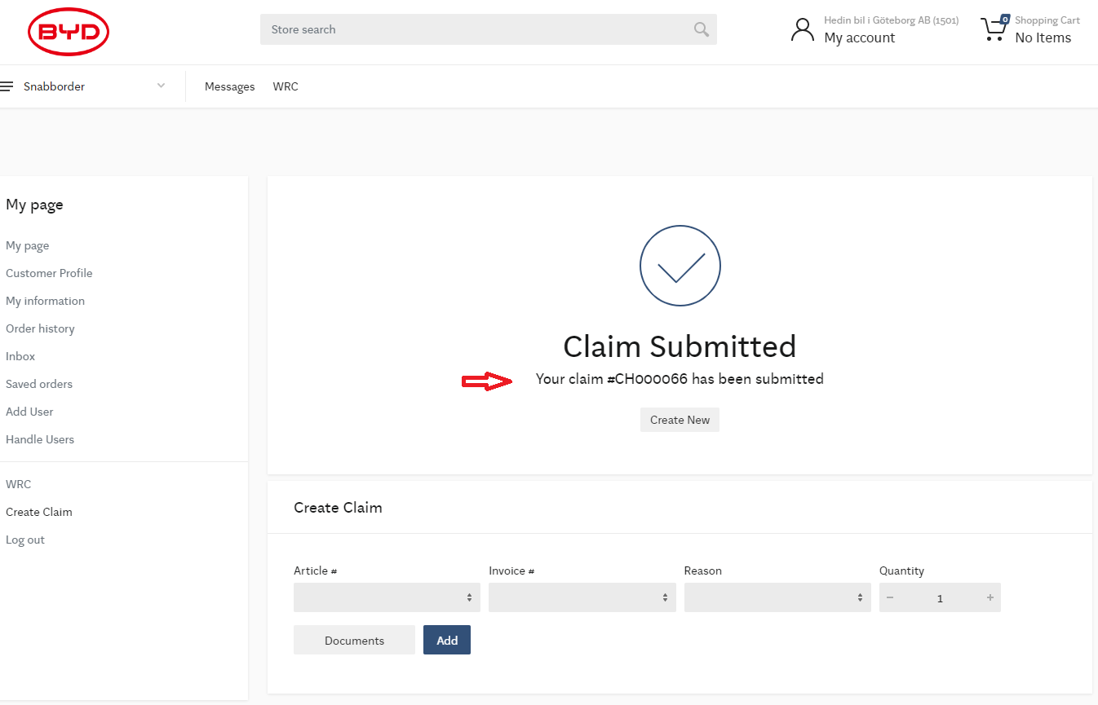

All registered claims can be found in the WRC page.
A new claim has the status submitted.
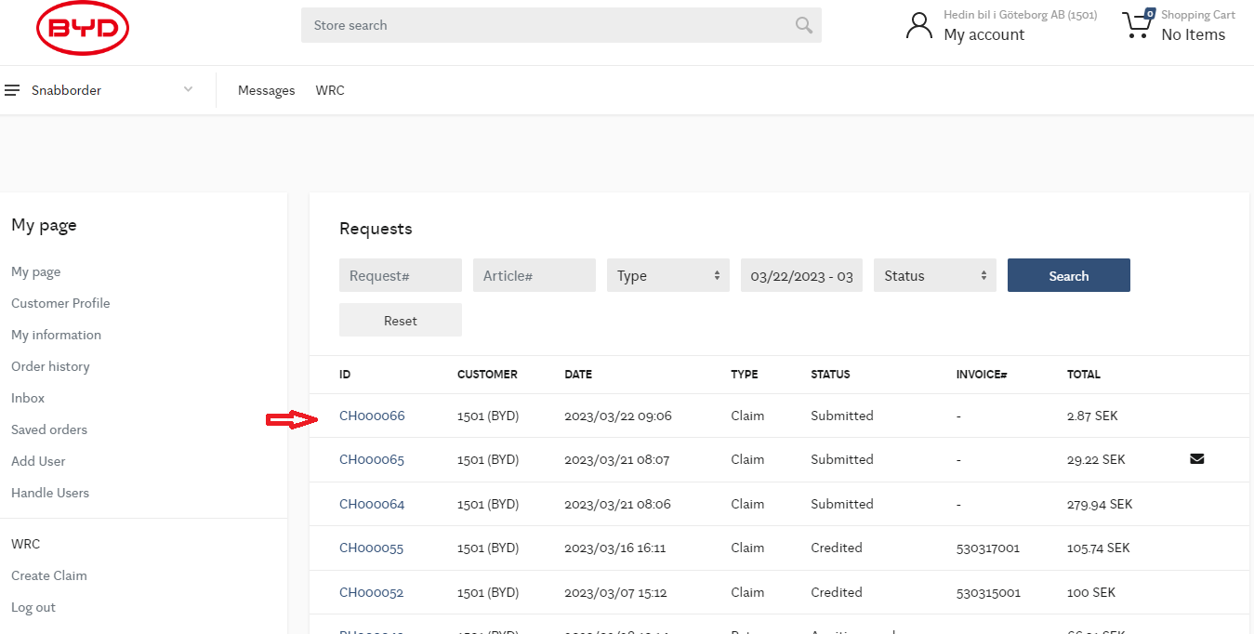

All communication with HPL regarding the submission is done within the claim.
In the comment field you can write notes about the claim, and you add the comment by clicking the “Post Comment” button.
With the “Documents” button you select documents and pictures that you want to add.
When a document has been selected, the button will change colour to blue.
Click “Post Comment” to upload the document to the claim. Also to make a comment with information about the uploaded documents and click “Post Comment”. Only 1 document or picture can be added each time. Repeat if more documents/ pictures need to be uploaded.

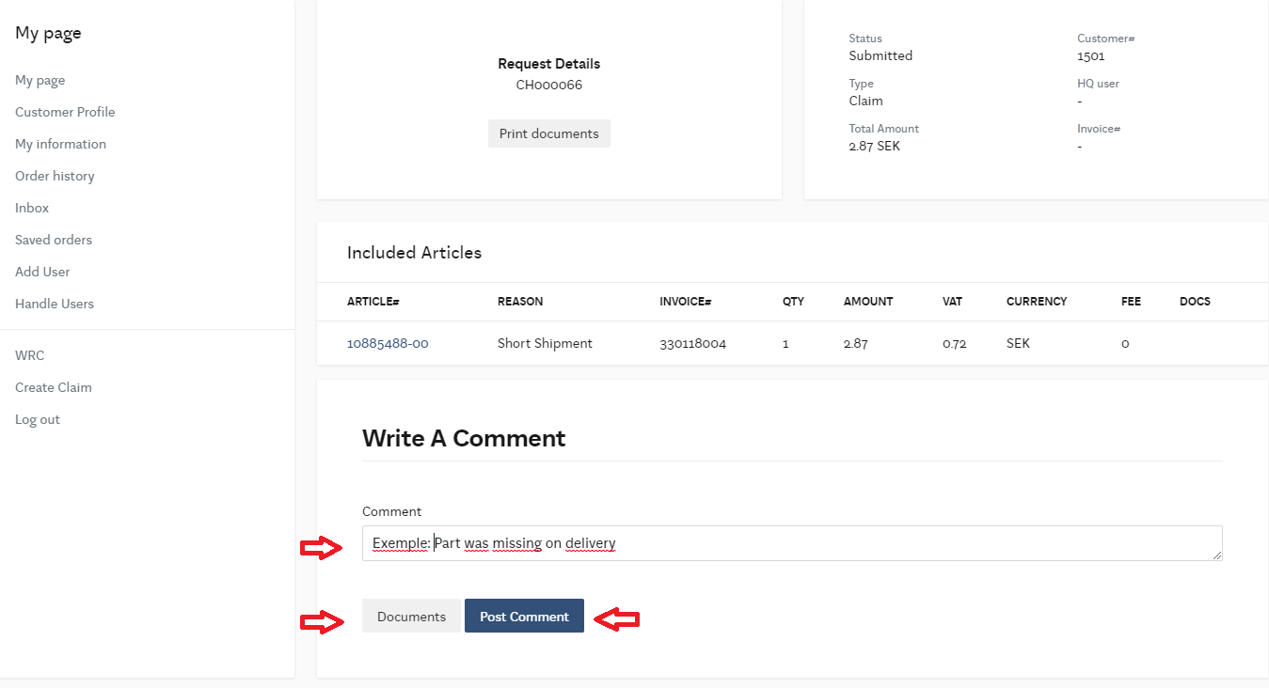

When HPL has looked at the case and commented, it can be seen as shown in the picture with the envelope symbol on the right hand side. A email notification will also be sent out to the user.
Open the claim to proceed.
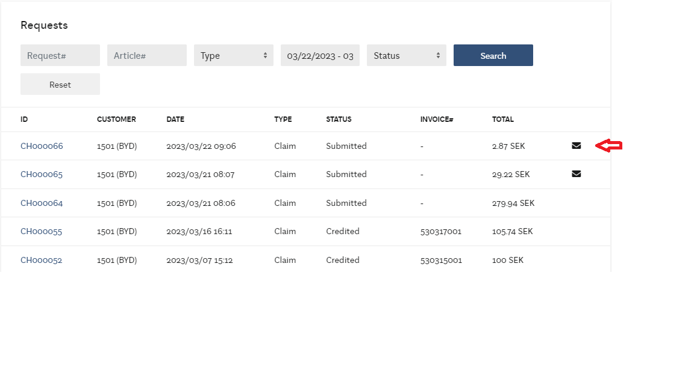
A conversation flow example:
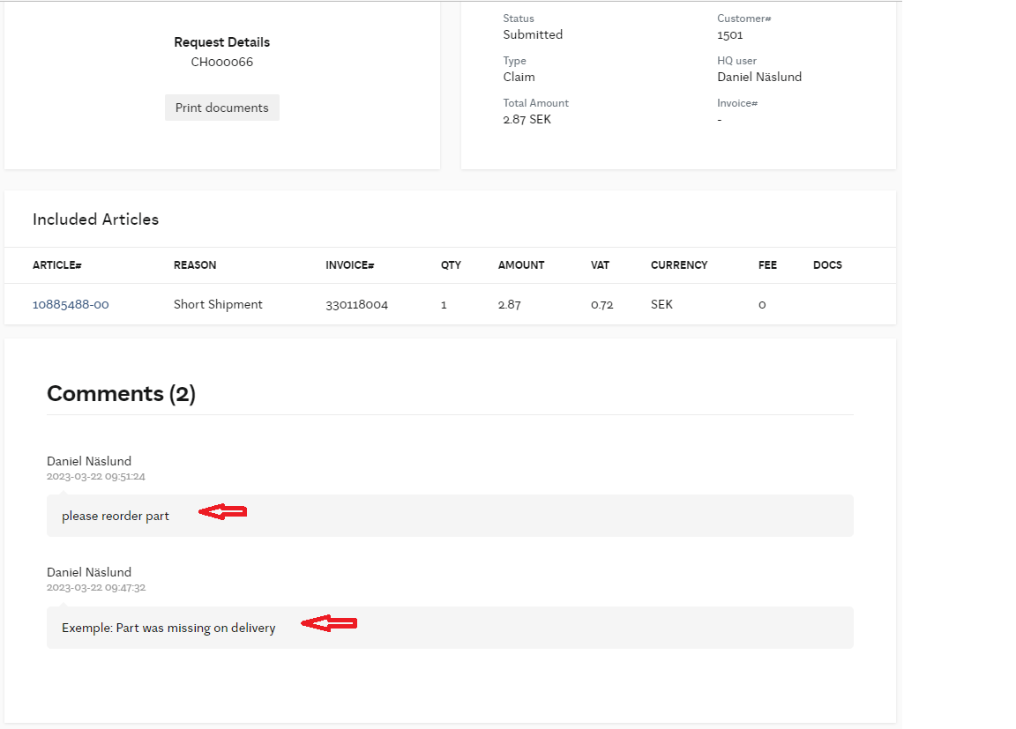

If HPL ask you to return a part, click the “Print documents” to print the transport document which you shall put it in the box.
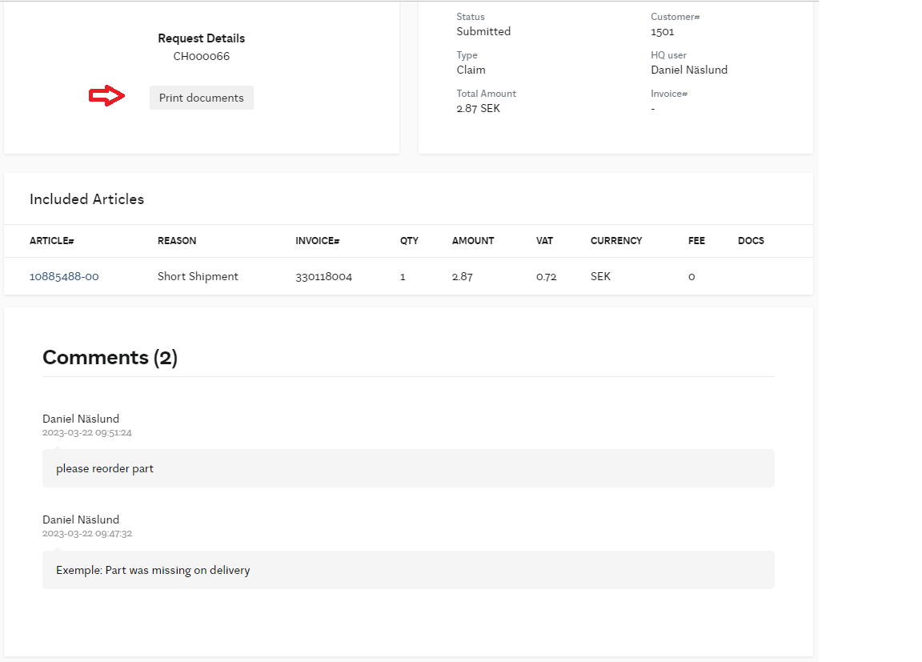

Explanation to the status in the delivery claim flow:
Submitted= The claim is sent and shall be managed by HPL.
Approved= The claim is approved and a credit order is created.
Credited= The claim is credited. The credit invoice number is noted.
Awaiting home shipment= HPL is waiting for the parts to arrive in the warehouse. Do not forget to print out the transport document in the claim and add this in the box. This will help HPL to manage a part return without delay.
Update requested = HPL has made a comment.
Rejected= HPL has rejected the delivery claim. See comments in the claim for the reason.
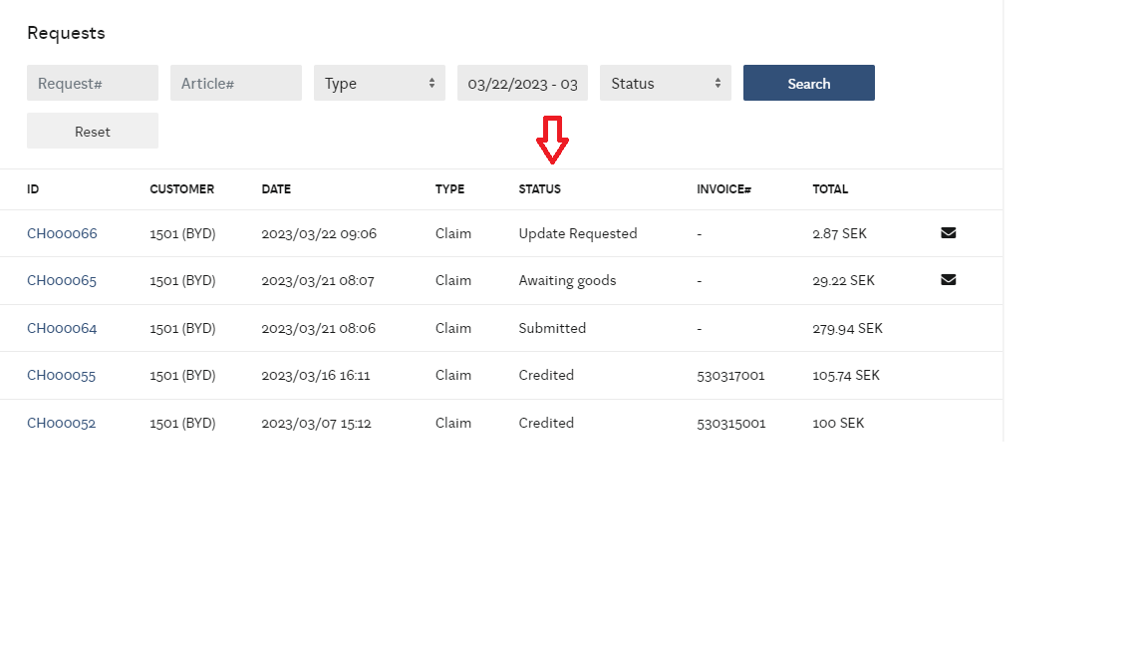

FAQ Regarding delivery complaints:
Q: How long do I have to make a delivery claim?
A: You have 30 days to create a delivery complaint in WRC from the order date.

Q: When should I make a delivery complaint if a delivery is not received as expected:

A: In cases where the package is missing =
Delivery not delivered. Or the package is missing from the delivery.
Contact your customer support for the region for tracking and submit a case immediately after you have confirmed the item parcel is missing/misrouted.

Q: When do I directly create a delivery complaint:
A: On tte below occasions, I immediately create a delivery complaint
Overdelivery = More number of items delivered than ordered.
Incorrectly labeled article/part.= Incorrectly labeled article/part.
Underdelivery = Missing number of items in the delivery.
Wrongly sent = Wrong part delivered.

Transport damage and Damaged goods:
All goods and parts must be checked immediately upon arrival.
Damage must be reported to the transporter directly in the event of obvious damage, or on its website as soon as the part in the package has been checked on the day of arrival.
If a damage report is not made immediately, the damaged goods may not be credited. Case number must be attached to the case in wrc.
In case of damage to parts, pictures must be taken of the damaged goods and packaging and attached to the case in wrc.

HPL Customer support Sweden: customer.support.nordic@hedinparts.com

