
Nyköping/Trollhättan / 2019.09.26

Saab Original Parts Information Update

Valid to: Until further notice
PI-number: 19-08-03

Bonnet lock wire, rear for 9-5 MY98-10 LHD
Wire 4855011 (pos30) isn’t possible to get complete with handle anymore. Please remove handle from old wire and mount on new wire. Portal is updated.
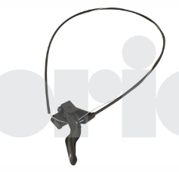

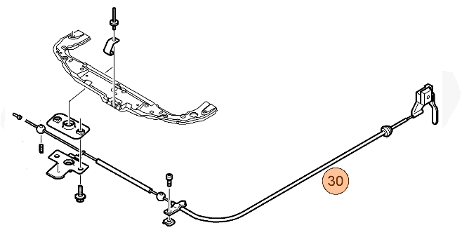
Contact us: WEB start.orio.com PHONE

