
Nyköping/Trollhättan / 2018.12.12

Saab Original Parts Information Update

Valid to: Until further notice
PI-number: 18-08-03

New kit for bumper panel front 9-5 MY10-11

To have availability of front bumper panels with headlamp washer, kits are created with necessary parts and instructions on how to make holes. Will get slightly different appearance.
Please order on new part number. See EPC, using old part number for complete information. Portal is updated.

Front bumper panel kit
Old part no. | New part no. | Description and usage | Old DN | New DN | New retail
12823491 | 32021826
12823496 | 32021827
12823497 | 32021828
12823490 | 32021845

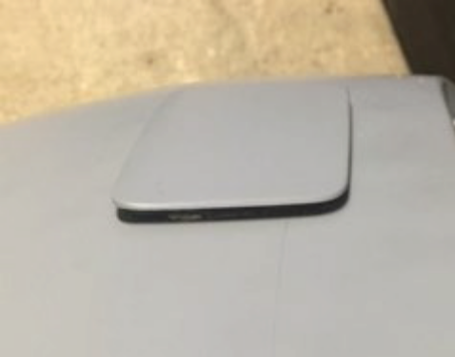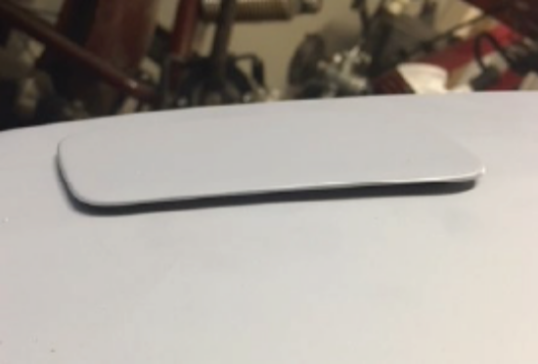

Contact us: WEB start.orio.com PHONE

