
Nyköping/Trollhättan / 2018.11.13

Saab Original Parts Information Update

Valid to: Until further notice
PI-number: 18-03-03

New reman program for 9-3 amplifier AMP1 MY03-06

To have availability for amplifier 12800531 and 12757370, a reman program for this is started. All amplifiers are reassembled, cleaned, repaired, tested and surface treated.
Please order on new part number. See EPC, using old part number for complete information. Portal is updated for parts we have in stock.

Due to lack of cores we cannot fulfill all orders immediately. We therefor ask for your assistance to return the cores if you consider them to be useable for remanufacturing. Our core charge is 500SEK (50,25€; 59,24$; 44,21£; 58,48CHF; 467,29NOK) and we will pay also for old cores not bought from Orio AB.

Amplifier AMP1
Old part no. | New part no. | Description and usage | Old DN | New DN | New retail
12800531 | 32020121
12757370 | 32020121

Used part

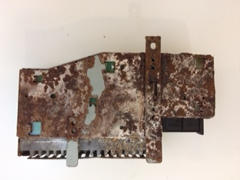

Reman part

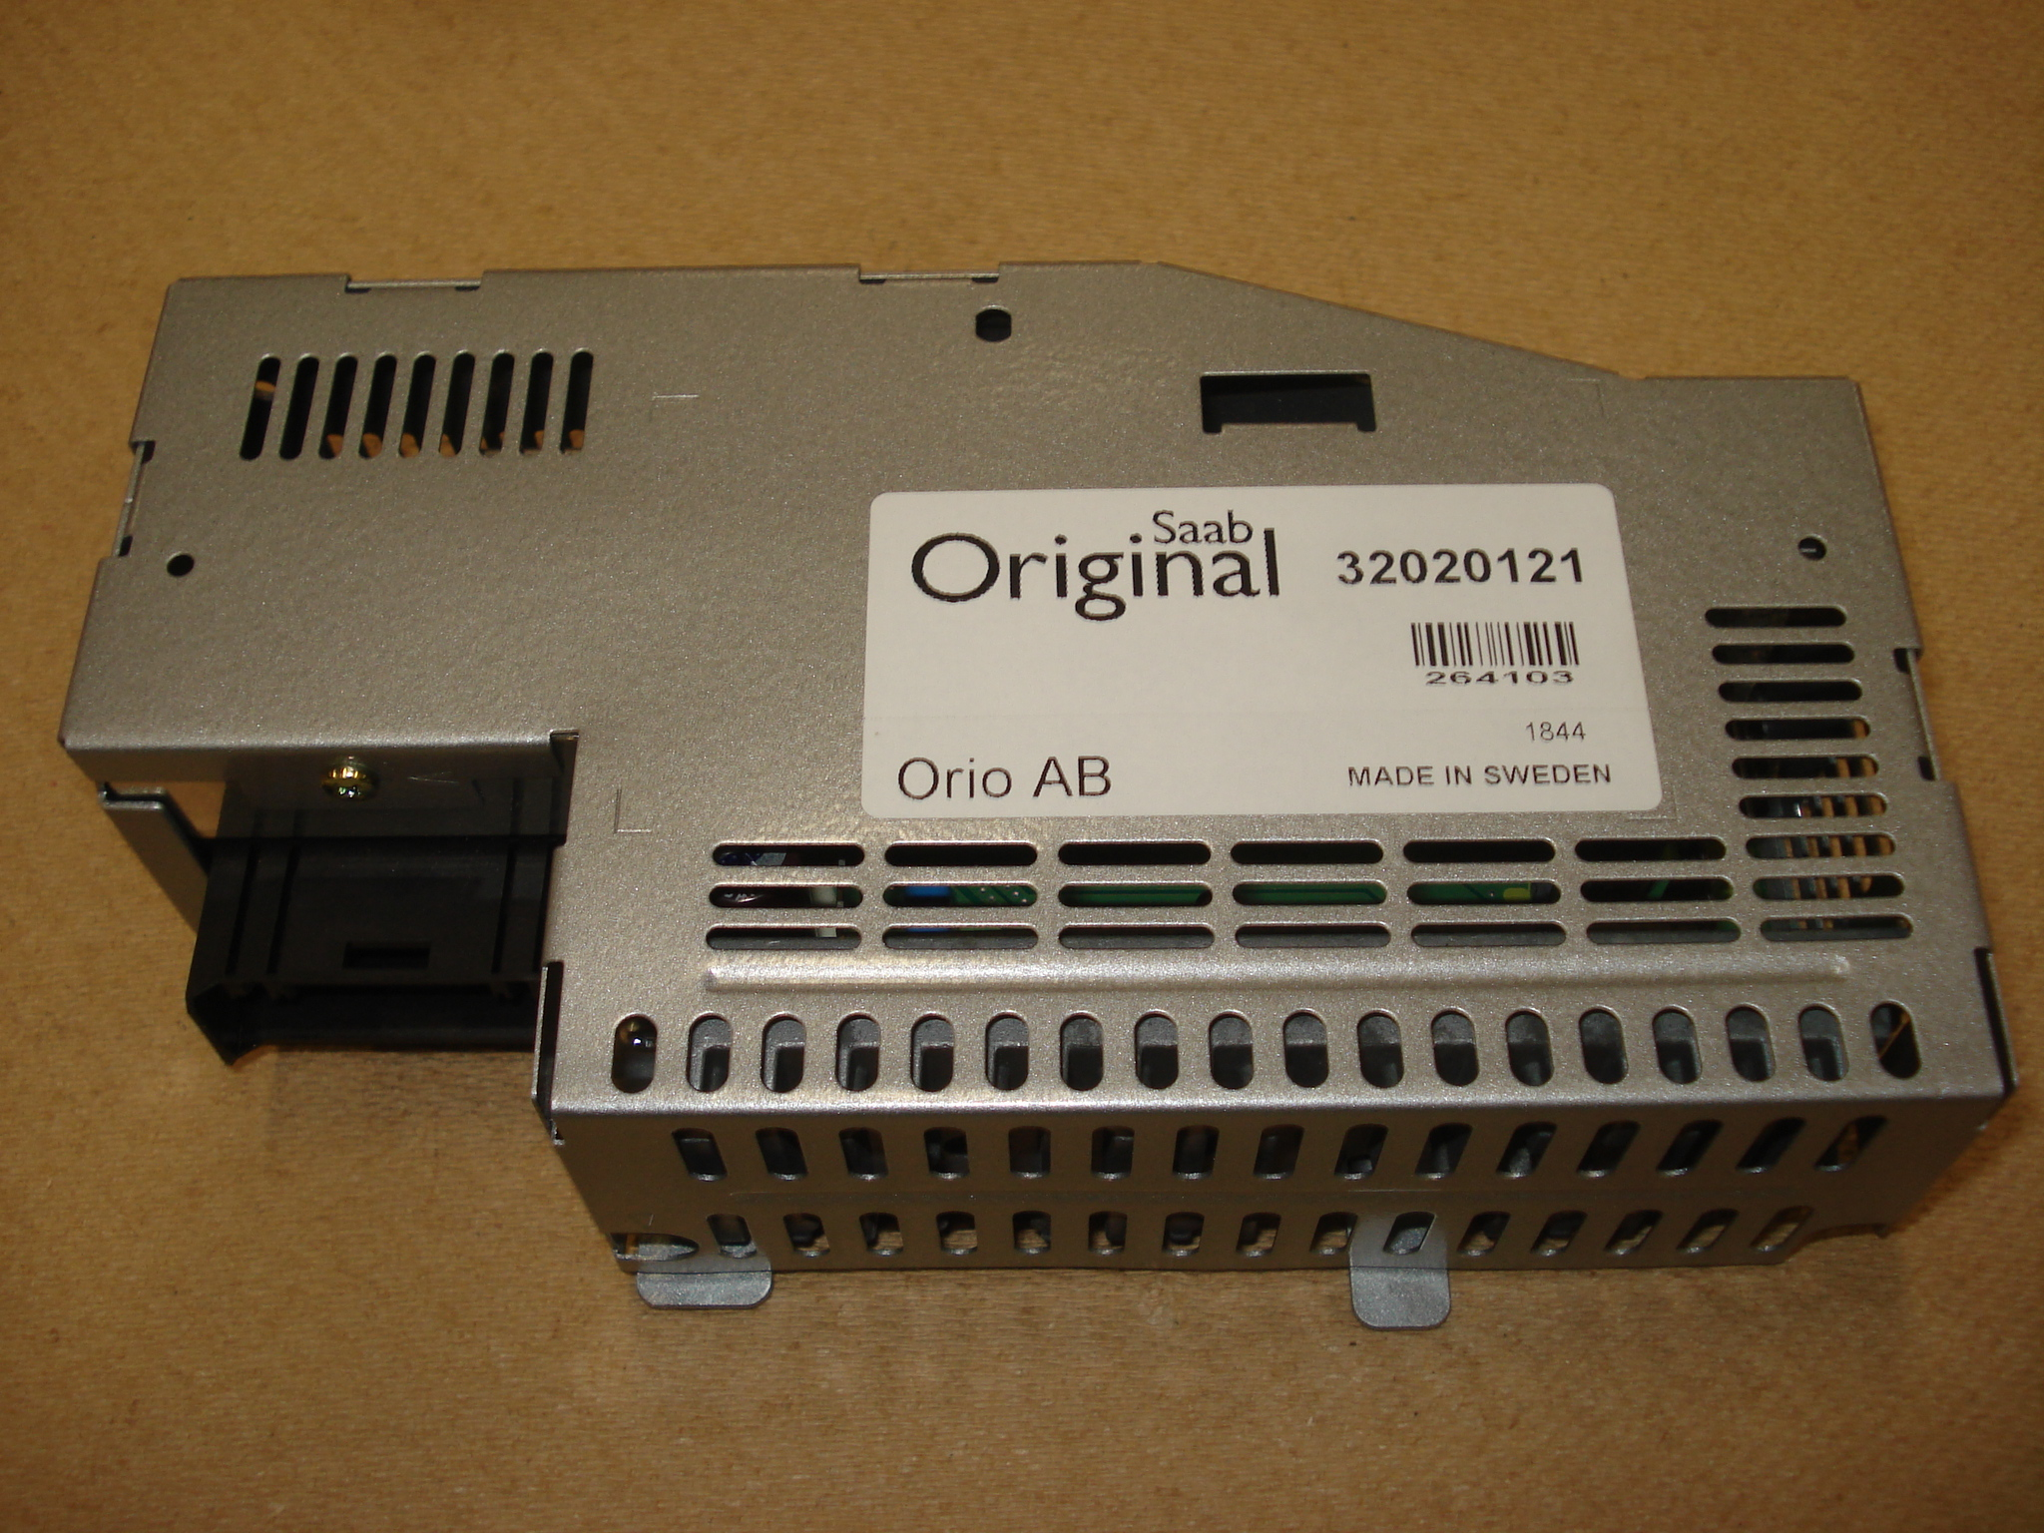

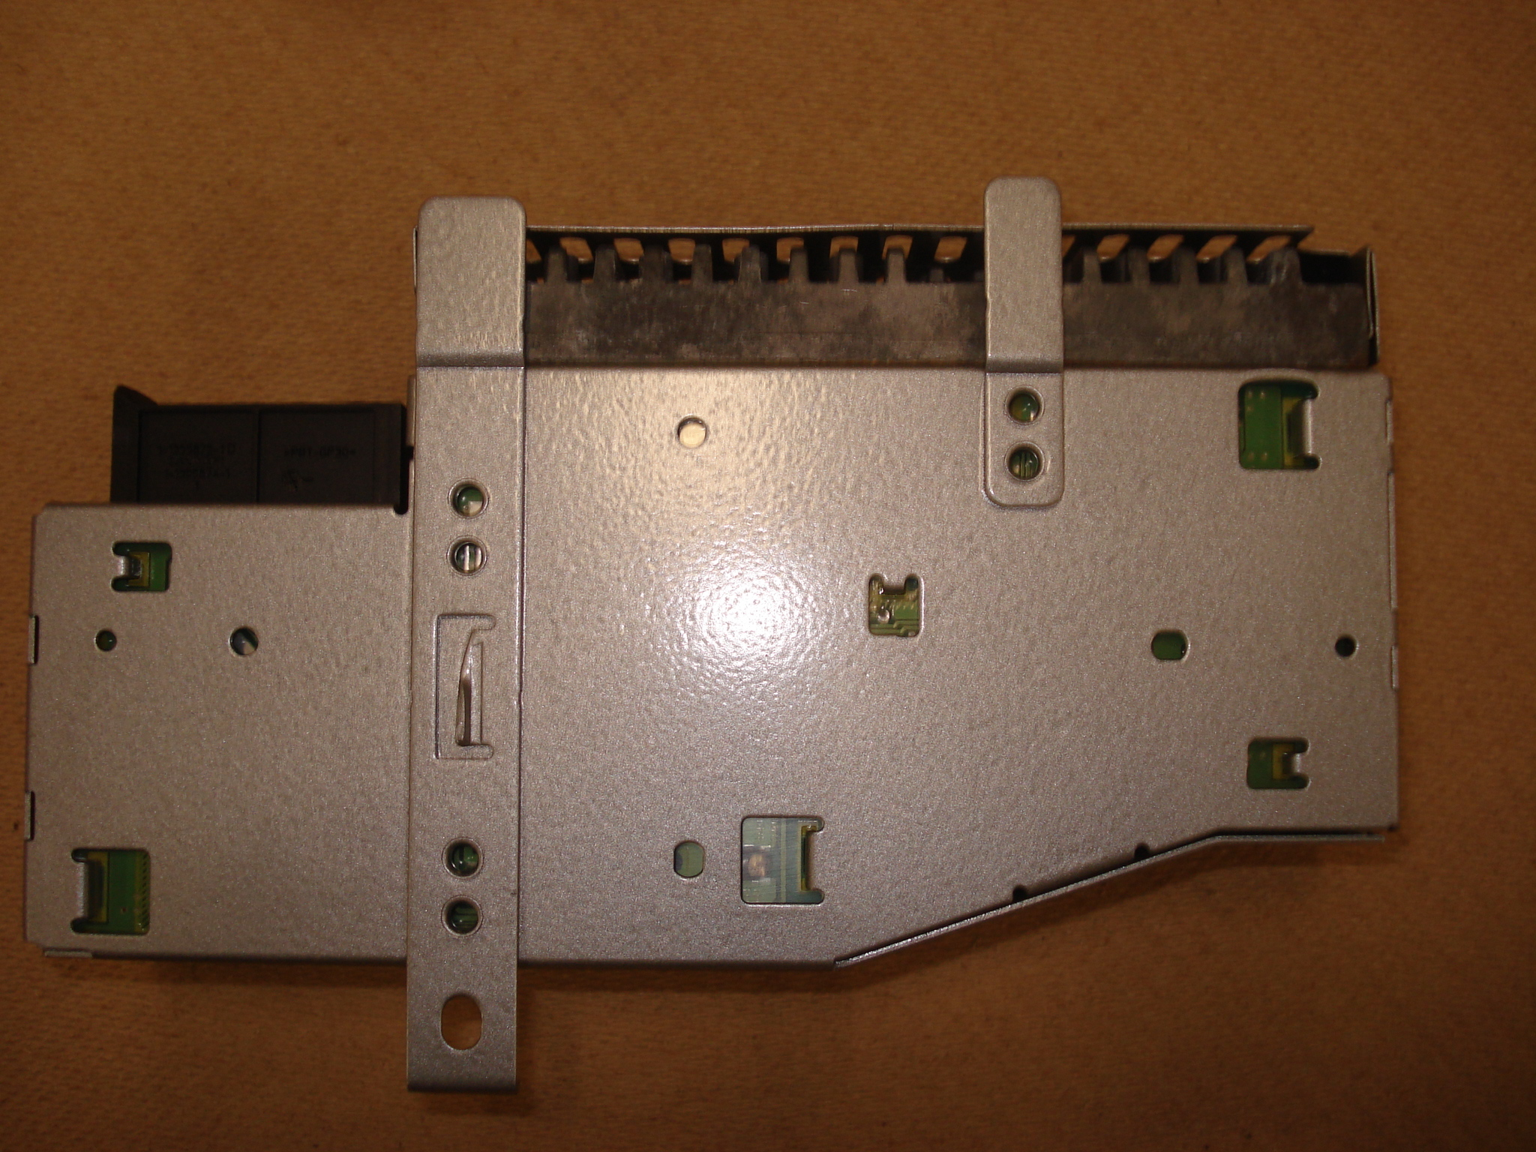

Contact us: WEB start.orio.com PHONE

