
Nyköping/Trollhättan / 2018.01.22

Saab Original Parts Information Update

Valid to: Until further notice
PI-number: 18-02-01

Fuel pump, fuel gauge for A20NFT 9-3 MY12 XWD
Position number for Fuel pump is missing in EPC. Please use Notes in EPC, to do an User note for these specific part numbers, see instructions in Help section.

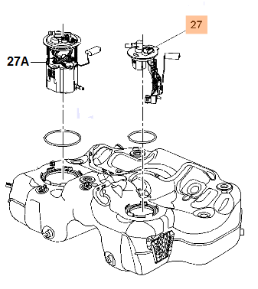
Contact us: WEB start.orio.com PHONE

