
Nyköping/Trollhättan / 2017.04.18

Saab Original Parts Information Update

Valid to: Until further notice
PI-number: 17-08-14

Décor strip 9-3 MY04-07 CV

It is no longer possible to get these parts from supplier. See table below for alternative variants.
Please note that these are painted and has a smooth structure. To have same structure as original, structure paint can be used.
Please order on new part number. See EPC, using old part number for complete information. Portal is updated.

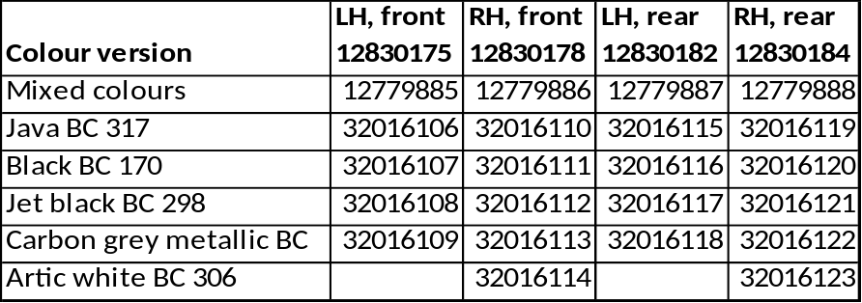

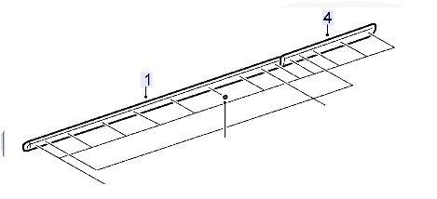
Contact us: WEB start.orio.com PHONE

