
Nyköping/Trollhättan / 2017.01.17

Saab Original Parts Information Update

Valid to: Until further notice
PI-number: 17-08-06

Cup holder for 9-3 MY03- LHD

We have been able to start production for Cup holder 32016105, pos18A. First deliveries are now in stock.

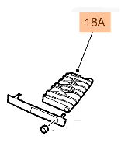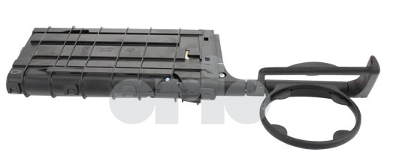

Contact us: WEB start.orio.com PHONE

