
Nyköping/Trollhättan / 2017.01.04

Saab Original Parts Information Update

Valid to: Until further notice
PI-number: 17-08-01

Belt catch for 900 MY90-93 rear seat

Not possible to get left side 9540352 pos10. Right side 9540360 can be used instead, but the red release button will be on the (wrong) other side of the belt tongue.

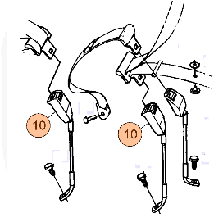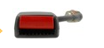

Contact us: WEB start.orio.com PHONE

