
Nyköping/Trollhättan / 2017.10.11

Saab Original Parts Information Update

Valid to: Until further notice
PI-number: 17-07-06

Ingoing bushings for Yoke, steering knuckle 9-5 MY10-11

It is now possible to buy ingoing parts for Yoke, pos13:
Pos13A 13411102 Bushing
Pos13B 13278765 King pin
Pos13C 13239684 Bushing

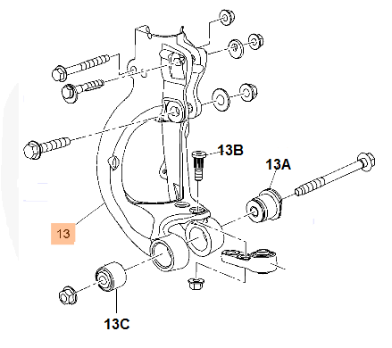

Contact us: WEB start.orio.com PHONE

