
Nyköping/Trollhättan / 2017.05.30

Saab Original Parts Information Update

Valid to: Until further notice
PI-number: 17-07-04

Shock absorber kit 900 -MY93

It is no longer possible to get this parts from supplier. We therefore introduce it as Saab Select type 57. Please order on new part number. See EPC, using old part number for complete information. Portal is updated.

Shock absorber kit
Old part no. | New part no.  (Saab Select) | Description and usage | Old DN | New DN | New retail
8993446 | 32020005 | Pos2
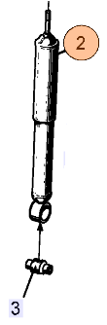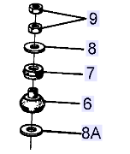

Contact us: WEB start.orio.com PHONE
· Selected for Saab by Saab experts
· Excellent quality & durability
· Easy to fit
· Reliability
Saab Select are alternative parts from leading suppliers, selected by our Saab experts. Saab Select enables you to continue taking care of Saabs in a safe and cost efficient way. You can be sure that all parts are selected for Saab. As an extra security we give you 2 years warranty on the complete range of products.

Saab Select are alternative parts from leading suppliers, selected by our Saab experts. Saab Select enables you to continue taking care of Saabs in a safe and cost efficient way. You can be sure that all parts are selected for Saab. As an extra security we give you 2 years warranty on the complete range of products.

