
Nyköping/Trollhättan / 2017.01.30

Saab Original Parts Information Update

Valid to: Until further notice
PI-number: 17-06-02

Steering column lock for 9-3 -31026543

12801116 (pos3) is no longer possible to get from supplier. To be able to use later variant, Column integrated module (pos23) also need to be changed, see table below.

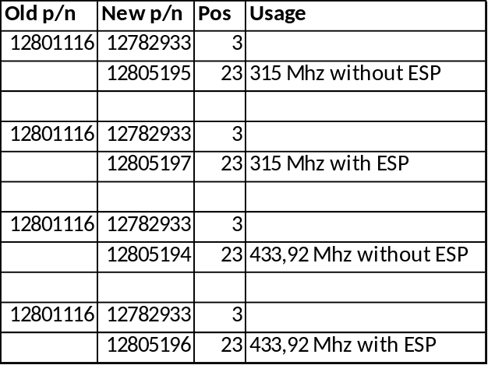
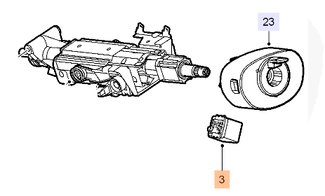
Contact us: WEB start.orio.com PHONE

