
Nyköping/Trollhättan / 2017.08.29

Saab Original Parts Information Update

Valid to: Until further notice
PI-number: 17-03-06

Engine start switch for 9-5 MY10-11

12768560 is out of stock. We have same switch but with blue illumination light, instead of green.
Please order on new part number 95480111. See EPC, using old part number for complete information. Portal is updated.

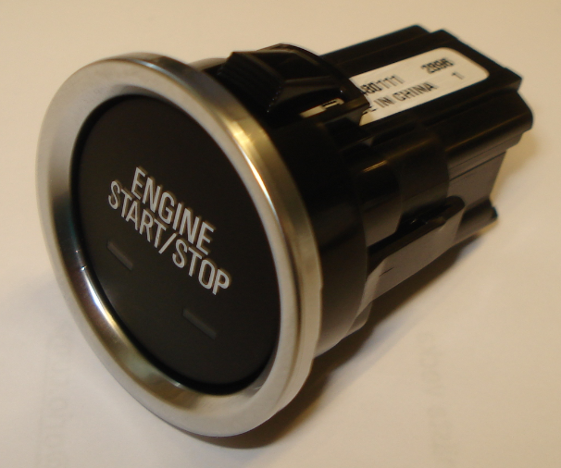

Contact us: WEB start.orio.com PHONE

