
Nyköping/Trollhättan / 2017.10.10

Saab Original Parts Information Update

Valid to: Until further notice
PI-number: 17-02-27

Vibration damper for 9-3 D223L MY98-02

Please note that red marked bracket below isn’t included in 32019218. This bracket needs to be moved from old vibration damper.

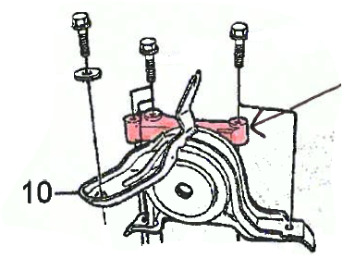


Contact us: WEB start.orio.com PHONE
· Selected for Saab by Saab experts
· Excellent quality & durability
· Easy to fit
· Reliability
Saab Select are alternative parts from leading suppliers, selected by our Saab experts. Saab Select enables you to continue taking care of Saabs in a safe and cost efficient way. You can be sure that all parts are selected for Saab. As an extra security we give you 2 years warranty on the complete range of products.

Saab Select are alternative parts from leading suppliers, selected by our Saab experts. Saab Select enables you to continue taking care of Saabs in a safe and cost efficient way. You can be sure that all parts are selected for Saab. As an extra security we give you 2 years warranty on the complete range of products.

