
Nyköping/Trollhättan / 2018.05.22

Saab Original Parts Information Update

Valid to: Until further notice
PI-number: 17-02-21

New reman program for catalytic converters
Ed2. We have sold most of our inventory for yellow marked parts below, but we don’t get the cores in return. Please send them as soon as possible to avoid back-orders.
To have availability for certain catalytic converters, a reman program for this is started. All converters are reassembled, cleaned and surface treated. A unique heating method is used to clean the converter inside. 4-gast test is used to checked CO and HC values. Parts are hand-blasted and painted. All parts are engraved with production year and month, unique ID number and new part number.
To regain the core cost, the catalytic converter must be complete and no damages for the actual steel cover for/and the honeycomb ceramic structure, but we accept minor damages, such as broken screws, damage flexi-pipe.
Please order on new part number. See EPC, using old part number for complete information. Portal is updated for parts we have in stock.

We are missing some cores to be able to have reman parts on stock. For all parts that we don’t have in stock, we pay core cost, even though no reman part is ordered.
Please return your core as soon as possible, to be able to have availability for the future.

Part no. | Reman p/n | Core cost SEK | In stock
55559798 | 32019974 | 1 100 | Yes
5323001 | 32019976 | 1 500 | No
5461025 | 32019978 | 1 200 | Yes
55559630 | 32019980 | 1 400 | No
12785060 | 32019982 | 1 400 | Yes
12802228 | 32019984 | 1 400 | Yes
55571012 | 32019986 | 1 500 | Yes
55565590 | 32019988 | 1 700 | No
55559584 | 32019990 | 1 700 | Yes
55559585 | 32019992 | 1 400 | No
12778166 | 32019994 | 2 200 | Yes
4962072 | 32019996 | 1 100 | No
4960191 | 32019998 | 1 100 | No
5325501 | 32020000 | 1 100 | Yes

Used part

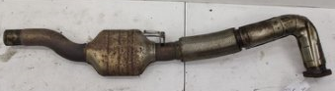

Reman part

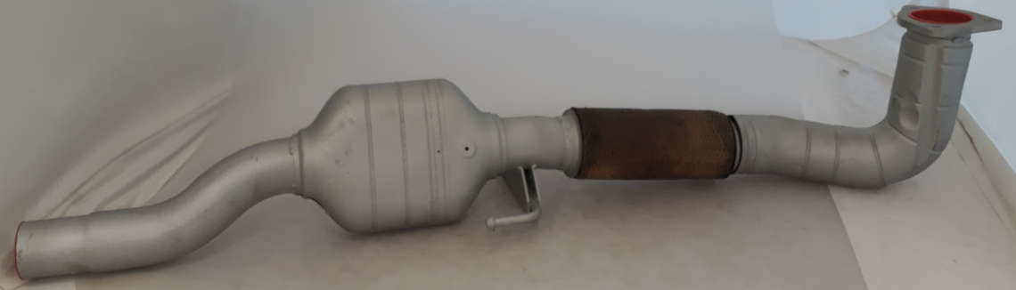

Contact us: WEB start.orio.com PHONE

