
Nyköping/Trollhättan / 2017.01.11

Saab Original Parts Information Update

Valid to: Until further notice
PI-number: 17-02-02

Ingoing part for belt tensioner for 9000
Part 4358149, Foundation platform pos4, is no longer possible to get from supplier. Complete unit 4901443 pos1 can be used instead. Please order on new part number. See EPC, using old part number for complete information. Portal is updated.

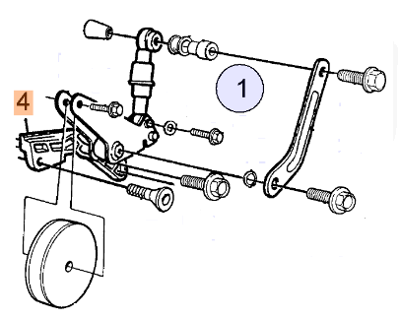

Contact us: WEB start.orio.com PHONE

