
Nyköping/Trollhättan / 2016.09.21

Saab Original Parts Information Update

Valid to: Until further notice
PI-number: 16-08-18

Label vehicle emission control
Label 12821635 is missing in EPC. It is valid for MY10 for new 9-5, for US, CA, MX with V6 engine. Is also valid for cars imported from US to other countries. Portal is updated.

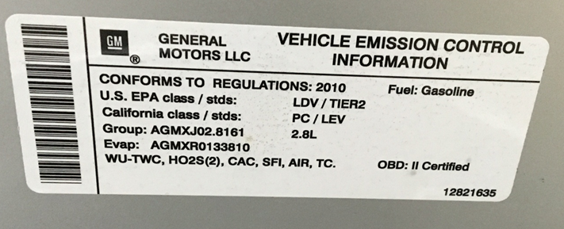

Contact us: WEB start.orio.com PHONE

