
Nyköping/Trollhättan / 2016.08.22

Saab Original Parts Information Update

Valid to: Until further notice
PI-number: 16-08-16

Seat belts for Saab 9-3 MY03-12

The delivery situation for these parts have been strained for a very long time.
Due to several issues, the supplier cannot deliver.
We are having regular meetings with the supplier to improve the situation.
We will keep you informed about the progress.

What can we do in the meantime?
Our Engineering team is working to reduce variants, which can give availability through supersessions. This will also help us in our communications with the supplier. Hope to have a first result during week 36.

We are also checking alternative supplier for these parts.

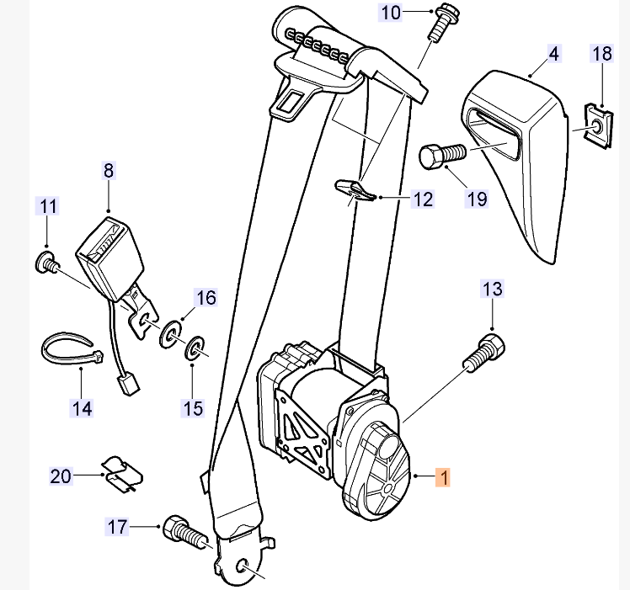

Contact us: WEB start.orio.com PHONE

