
Nyköping/Trollhättan / 2016.06.14

Saab Original Parts Information Update

Valid to: Until further notice
PI-number: 16-08-13

Parts information – Sunroof 12768735 for 9-3 MY06-12
The price for Sunroof 12768735 have been reduced by more than 3 times due to overstock. As we are missing some of the ingoing components we hope that this can help, even though the reduced price doesn’t match the price for ingoing parts.

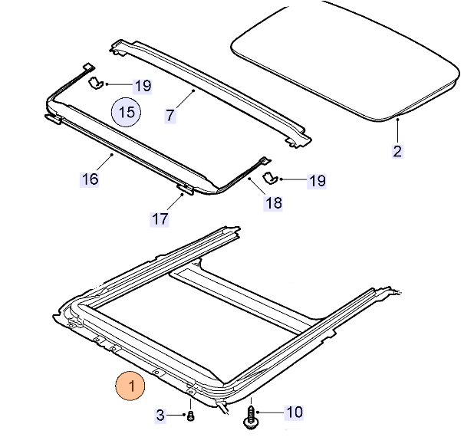

Contact us: WEB start.orio.com PHONE

