
Nyköping/Trollhättan / 2016.05.23

Saab Original Parts Information Update

Valid to: Until further notice
PI-number: 16-08-11

Parts information – Parcel shelf for 9-5 MY06-10
Parcel shelf for all markets except US, CA and AU is no longer possible to get from supplier.
US version can be used instead. The only difference is 3 covers for the child seat anchorage.
Portal will be updated.

Old part no. | New part no. | Description and usage | Old DN | New DN | New retail
12764325 | 12766135

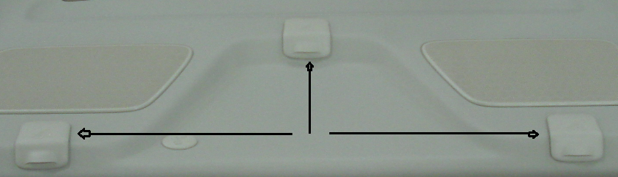

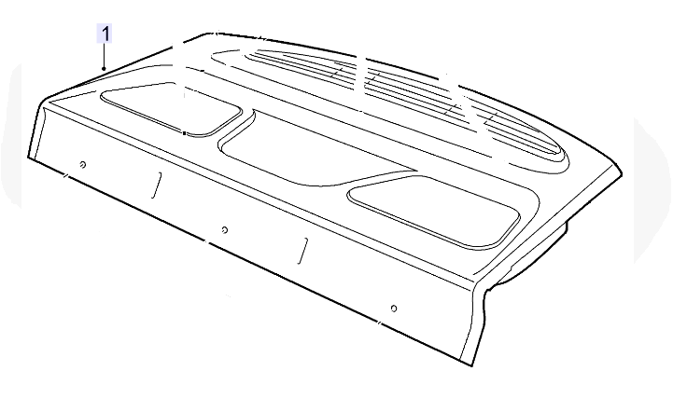

Contact us: WEB start.orio.com PHONE

