
Nyköping/Trollhättan / 2016.08.19

Saab Original Parts Information Update

Valid to: Until further notice
PI-number: 16-08-10

Bumper parts for 9-3 and old 9-5
Ed5. 32016144/145 will at last be in stock during week 35. Spoiler 32016151 will also be in stock during week 35. Please note solution for MY08-11 front bumper, 32016146/-147/-148/-149/-157/-158, see below for more information.
Ed4. 32016144/145 will probably be delayed 1 week. We will have smaller quantities for 32016280/281 and 32016160/166/172 in stock week 28/29.
Ed3. 32016138/139/140 will be produced and sent to Nyköping during week 27. 32016144/145 will be produced and sent to Nyköping during week 28.
Ed2. 348 pieces of 32016141 will be produced next week and sent to Nyköping. Should be available beginning week 26.
Please note that we have more than 100 backorders for 32016140, where 32016138 (100 in stock) can be used, if hole for headlamp washer is done manually.
The delivery situation for these parts have been strained for a very long time. Since last August we have been in numerous meetings with the supplier in order to find different solutions to help the situation.
Top management meetings with the supplier have also taken place to emphasize the critical situation.
During the last weeks the situation has been even worse, with no supplies at all and no delivery outlook from the supplier. Weekly meetings are held with the supplier to improve the situation and hopefully we will have more positive information within a couple of weeks. We will keep you informed about the progress.

What can we do in the meantime?
Bumpers in general
Front bumpers are normally in 2 variants, with or without headlamp washer. For variants with headlamp washer, the equivalent model without hole for headlamp washer can be used, but the hole must be done manually, see photo below.

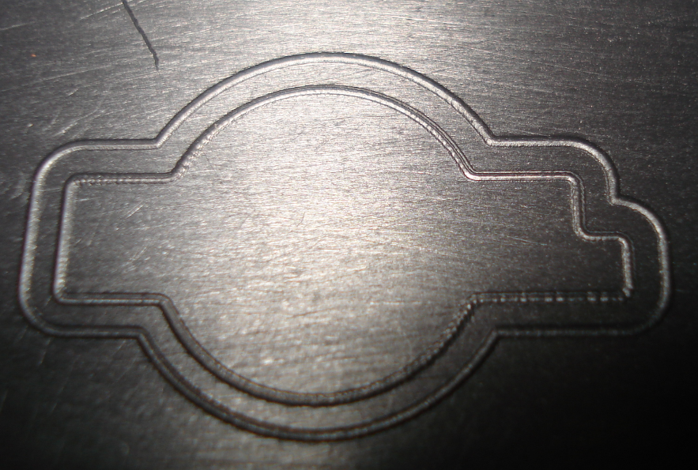

Rear bumpers, 9-5 MY06-10 and 9-3 MY08-12 have variants for Parking assistance. For variants with Parking assistance, the equivalent model without hole for parking sensors can be used, but the hole must be done manually. For instructions, see WebWIS, Accessories, Traffic safety system

9-3 MY08-11 front bumper
We have two different Griffin upgrade kits, 32027510 (with headlamp washer) and 32027511 (without headlamp washer) which can be used instead of the following parts; 32016146/-147/-148/-149/-157/-158. These are the variants for MY12, and a complete kit is to be recommended to use. For kit contents and photo see below. The price for the kits will during this period be adjusted, latest on May 23rd.
Please note that this is a complete kit with all necessary parts. Normally when a bumper panel is needed to be replaced, more parts are usually damaged and changed. The price difference between a complete kit and damage parts are then not significant.

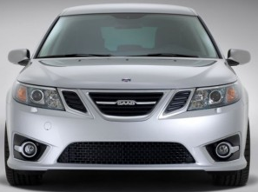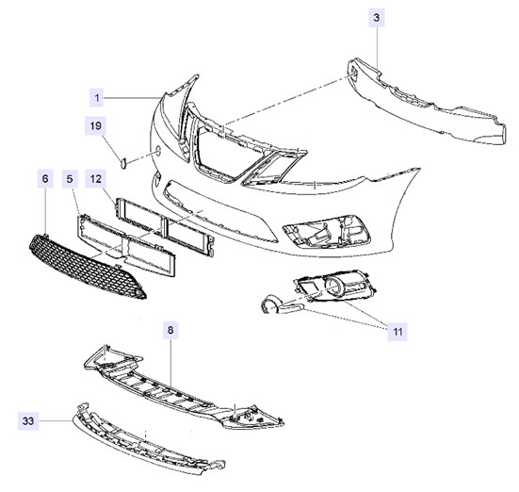

Contact us: WEB start.orio.com PHONE

