
Nyköping/Trollhättan / 2016.09.06

Saab Original Parts Information Update

Valid to: Until further notice
PI-number: 16-08-10

Bumper parts for 9-3 and old 9-5
Ed19 32016143/184/193 will be in stock week 12-13
Ed18 32016157/158 will be in stock in large quantities week 11-12
Ed17 32016161/162 will be in stock in large quantities week 10

What can we do in the meantime?
Bumpers in general
Front bumpers are normally in 2 variants, with or without headlamp washer. For variants with headlamp washer, the equivalent model without hole for headlamp washer can be used, but the hole must be done manually, see photo below.

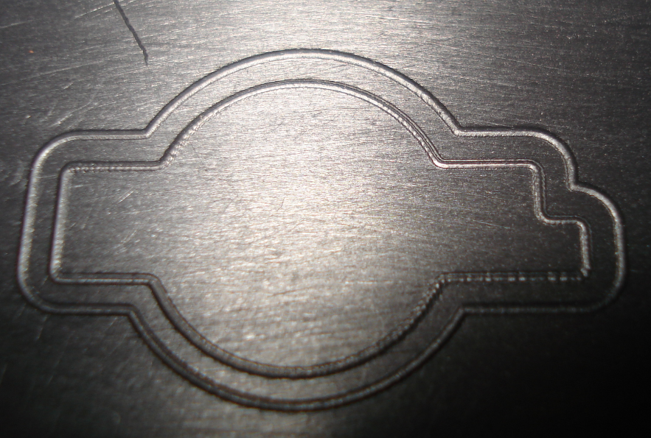

Rear bumpers, 9-5 MY06-10 and 9-3 MY08-12 have variants for Parking assistance. For variants with Parking assistance, the equivalent model without hole for parking sensors can be used, but the hole must be done manually. For instructions, see WebWIS, Accessories, Traffic safety system

9-3 MY08-11 front bumper
We have two different Griffin upgrade kits, 32027510 (with headlamp washer) and 32027511 (without headlamp washer) which can be used instead of the following parts; 32016146/-147/-148/-149/-157/-158. These are the variants for MY12, and a complete kit is to be recommended to use. For kit contents and photo see below.
Please note that this is a complete kit with all necessary parts. Normally when a bumper panel is needed to be replaced, more parts are usually damaged and changed. The price difference between a complete kit and damage parts are then not significant.

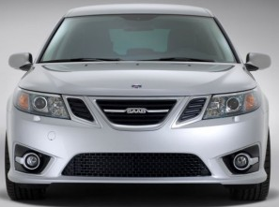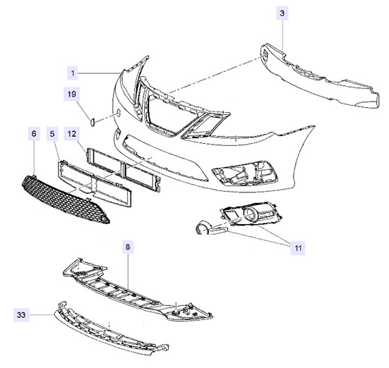

Contact us: WEB start.orio.com PHONE

