
Nyköping/Trollhättan / 2016.02.04

Saab Original Parts Information Update

Valid to: Until further notice
PI-number: 16-08-05

Door mirror glass in Auto Dimming for 9-5 and 9-3

We have previously made a kit for Auto dimming mirror glass to fit MY03-09, see PI 15-08-12. When existing stocks are exhausted parts will be NLS. We therefore introduce them as Saab Select type 57. The new glasses are Auto Dimming, but the view in the mirror is slightly different. Please order on new part number. See EPC, using old part number for complete information.
Old part no. | New part no.  (Saab Select) | Description and usage | Old DN | New DN | New retail
32019313 | 32019478 | Kit for MY03-09, LH, LHD, 9-3/9-5
12845642 | 32019476 | Glass MY10-, LH, LHD

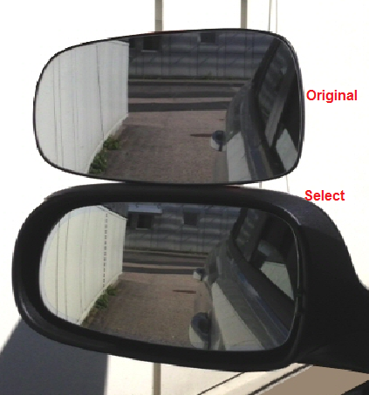


Saab Select are alternative parts from leading suppliers, selected by our Saab experts. Saab Select enables you to continue taking care of Saabs in a safe and cost efficient way. You can be sure that all parts are selected for Saab. As an extra security we give you 2 years warranty on the complete range of products.

Contact us: WEB orio.com/portal PHONE
· Selected for Saab by Saab experts
· Excellent quality & durability
· Easy to fit
· Reliability

