
Nyköping/Trollhättan / 2016.11.09

Saab Original Parts Information Update

Valid to: Until further notice
PI-number: 16-07-04

Spring, rear suspension for 9-3 MY06- and 9-5 MY06-10

It is no longer possible to get these parts from supplier. We therefore introduce them as Saab Select type 57. Please order on new part number. See EPC, using old part number for complete information. Portal is updated.

Spring, rear suspension
Old part no. | New part no.  (Saab Select) | Description and usage | Old DN | New DN | New retail
12760111 | 32055629 | Pos17, 9-5
12798996 | 32055177 | Pos5, 9-3
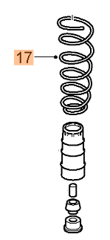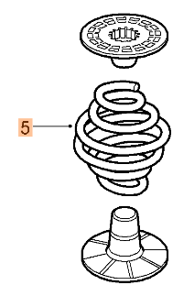


Saab Select are alternative parts from leading suppliers, selected by our Saab experts. Saab Select enables you to continue taking care of Saabs in a safe and cost efficient way. You can be sure that all parts are selected for Saab. As an extra security we give you 2 years warranty on the complete range of products.

Contact us: WEB start.orio.com PHONE
· Selected for Saab by Saab experts
· Excellent quality & durability
· Easy to fit
· Reliability

