
Nyköping/Trollhättan / 2016.04.27

Saab Original Parts Information Update

Valid to: Until further notice
PI-number: 16-04-02

Clutch wire service kit, RHD, 900 MY94-97 V6
Including part 4903290 (pos42) is no longer available. Kit 4903647(pos19) will therefore be built without this bracket. Most cars will however, not be effected by this change.

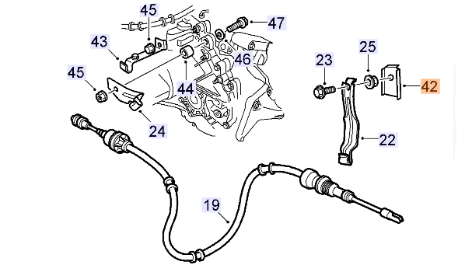

Contact us: WEB start.orio.com PHONE

