
Nyköping/Trollhättan / 2016.10.26

Saab Original Parts Information Update

Valid to: Until further notice
PI-number: 16-03-09

Seal side indicator lamp 900, 9000, 9-3 -MY03, 9-5 -MY05

9124140 was previously NLS, but we have now been able to get this part from the supplier again. Please update your local DMS system. Portal is updated.

Seal side indicator lamp
Old part no. | New part no. | Description and usage | Old DN | New DN | New retail
9124140 |  | Pos5
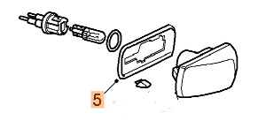

Contact us: WEB start.orio.com PHONE

