
Nyköping/Trollhättan / 2016.10.06

Saab Original Parts Information Update

Valid to: Until further notice
PI-number: 16-03-07

Tail lamp 900 MY94-98 3D, 5D

It is no longer possible to get this part from supplier. Please order on new part number.
The only difference is that US variant has side marker lights.
See EPC, using old part number for complete information. Portal is updated.

Tail lamp
Old part no. | New part no. | Description and usage | Old DN | New DN | New retail
4468955 | 4468971
4468963 | 4468989
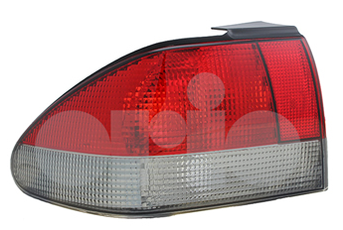

Contact us: WEB start.orio.com PHONE

