
Nyköping/Trollhättan / 2016.06.21

Saab Original Parts Information Update

Valid to: Until further notice
PI-number: 16-03-05

Switch for 9-3 MY07
The part numbers below were previously NLS, but we have now been able to relabel other variants or supersede. Please update your local DMS system. See EPC, using old part number for complete information. Portal is updated.

Switch
Old part no. | New part no. | Description and usage | Old DN | New DN | New retail
12763713 |  | Pos4
12763714 |  | Pos4
12763715 | 12847303 | Pos4
12763719 |  | Pos4
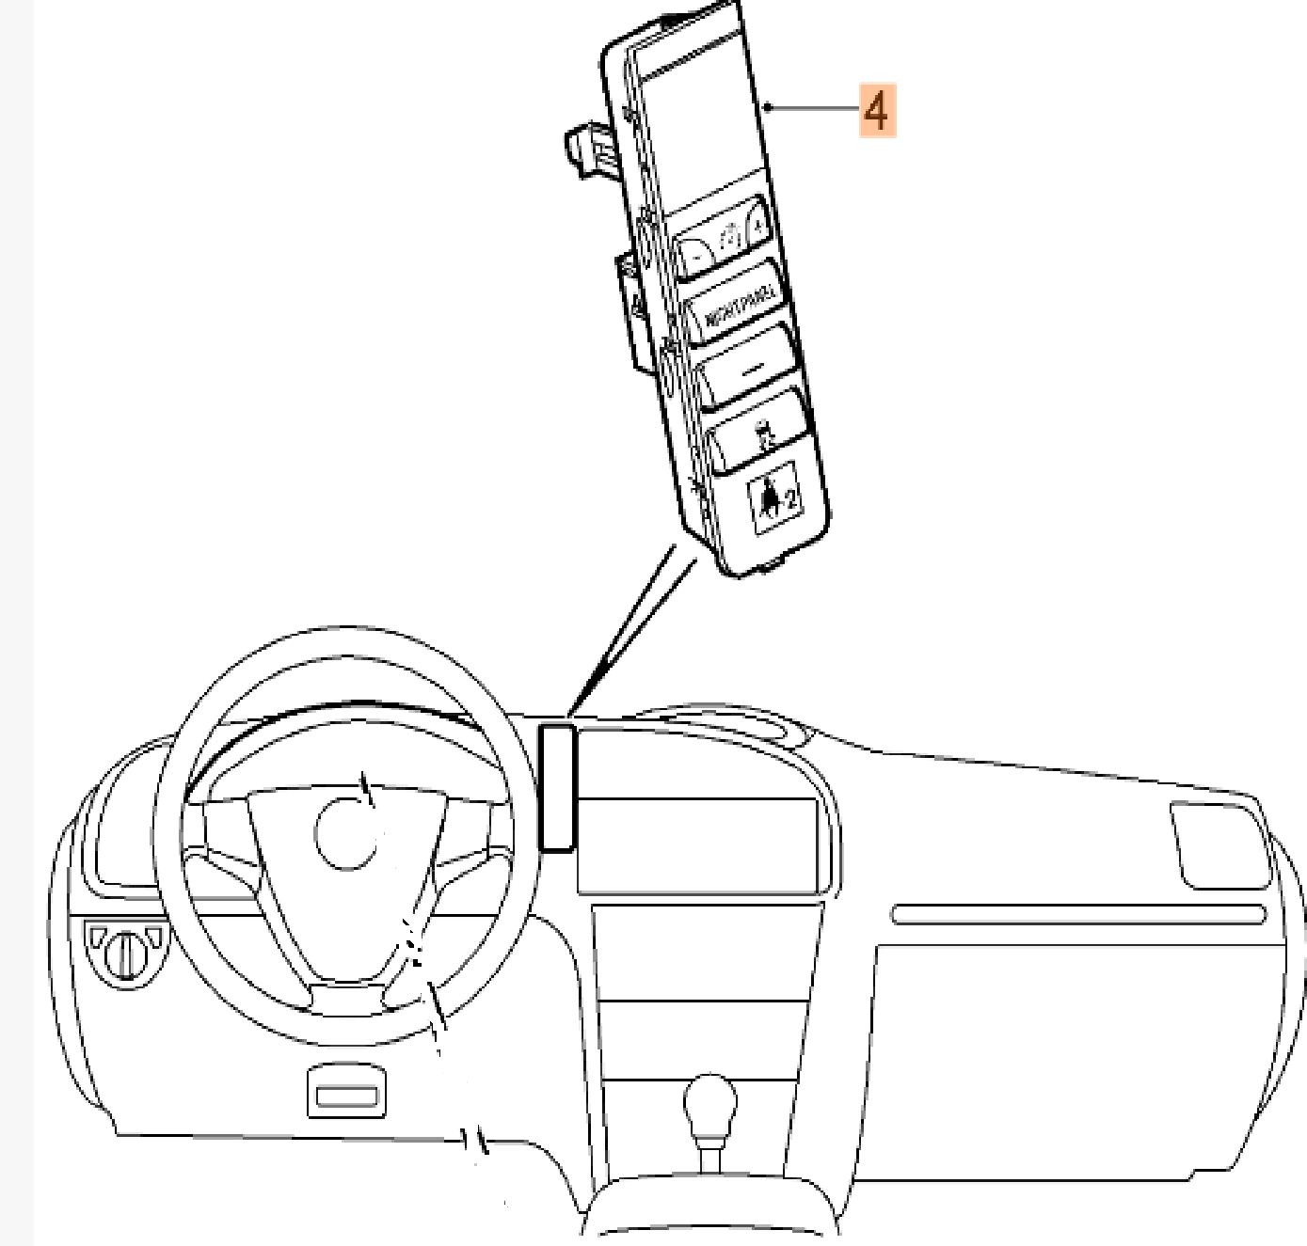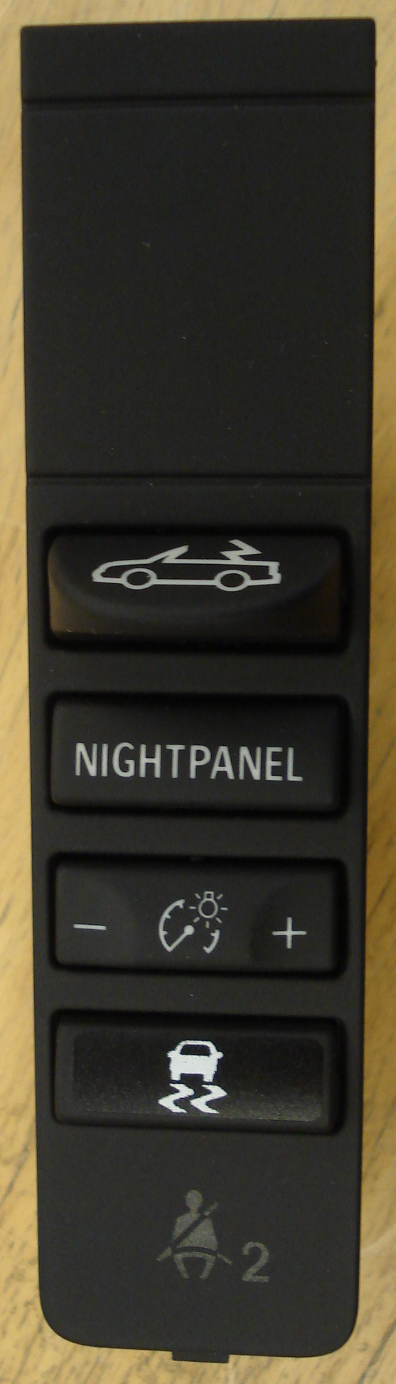
Contact us: WEB start.orio.com PHONE

