
Nyköping/Trollhättan / 2016.06.13

Saab Original Parts Information Update

Valid to: Until further notice
PI-number: 16-03-04

Electrical distribution unit (UHEC) for 9-3 MY03-12
For the moment we have several variants on back order. After investigation, we can supersede these to latest version + a symbolic instruction. Dealers need to check the variant they have in the car and compare with 12824877. If any relay or fuse is missing, these shall be moved to 12824877. If there to many relays or fuses in 12824877, these shall be removed.
Following part numbers are affected: 12767111/113/115, 12783069/072, 12783252/254/256, 12824878.
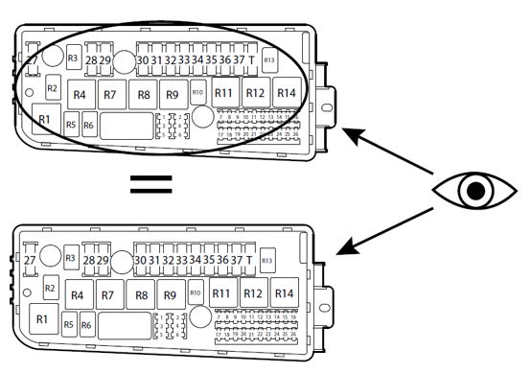
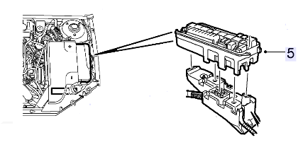
Contact us: WEB start.orio.com PHONE

