
Nyköping/Trollhättan / 2016.12.22

Saab Original Parts Information Update

Valid to: Until further notice
PI-number: 16-02-27

Cylinder head gasket for 900/9000 -MY93 B202/B234

It is no longer possible to get these parts from supplier. We therefore introduce them as Saab Select type 57. Please order on new part number. See EPC, using old part number for complete information. Portal is updated.
Cylinder head gasket/gasket kit
Old part no. | New part no.  (Saab Select) | Description and usage |  | Old DN |  | New DN |  |  | New retail
9181348 | 32019892 | Pos18
8819831 | 32019893 | Pos2
9321605 | 32019894 | Pos2
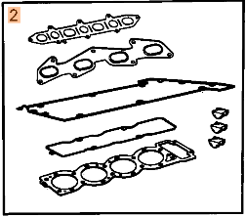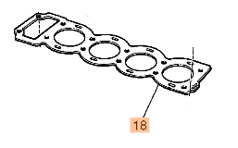

Contact us: WEB start.orio.com PHONE
· Selected for Saab by Saab experts
· Excellent quality & durability
· Easy to fit
· Reliability
Saab Select are alternative parts from leading suppliers, selected by our Saab experts. Saab Select enables you to continue taking care of Saabs in a safe and cost efficient way. You can be sure that all parts are selected for Saab. As an extra security we give you 2 years warranty on the complete range of products.

