
Nyköping/Trollhättan / 2016.09.07

Saab Original Parts Information Update

Valid to: Until further notice
PI-number: 16-02-13

Engine control module 9-3 B207

It is no longer possible to get this part from supplier.
When existing stocks are exhausted parts will be NLS and introduced as Reman program. Please order on new part number. See EPC, using old part number for complete information. Portal is updated.

Engine control module
Old part no. | New part no. | Description and usage | Old DN | New DN | New retail
55571182 | 32019553 | Pos1
55567903 | 32019554 | Pos1

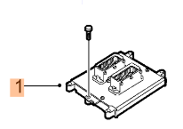
Contact us: WEB start.orio.com PHONE

