
Nyköping/Trollhättan / 2016.05.27

Saab Original Parts Information Update

Valid to: Until further notice
PI-number: 16-02-09

Piston rings set B207E/L for 9-3

It is no longer possible to get this part from supplier. When existing stocks are exhausted parts will be NLS and introduced as Saab Select type 57. Please order on new part number. See EPC, using old part number for complete information. Portal is updated.

Piston rings set
Old part no. | New part no.  (Saab Select) | Description and usage | Old DN | New DN | New retail
93180138 | 32019629 | B207E, B207L

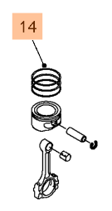

Contact us: WEB start.orio.com PHONE
Saab Select are alternative parts from leading suppliers, selected by our Saab experts. Saab Select enables you to continue taking care of Saabs in a safe and cost efficient way. You can be sure that all parts are selected for Saab. As an extra security we give you 2 years warranty on the complete range of products.

· Selected for Saab by Saab experts
· Excellent quality & durability
· Easy to fit
· Reliability
Contact us: WEB start.orio.com PHONE

