
Nyköping/Trollhättan / 2015.09.28

Parts Information

Valid from: Today
Valid to: Until further notice
PI-number: 15-03-12

Parts information – Siren Anti-theft Alarm TWICE, 32016206, Saab 9-5 MY 98 – 10,
Saab 9-3 MY98 – 03,

We have recently received complaints regarding siren 32016206, as it does not work after being installed in the car.
When those parts were returned and tested, there were no faults showing.

Please therefore check that the “Siren function” is not removed in TWICE.

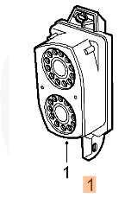

Per Gustafsson
Product Manager
Supply Chain Management

