
Nyköping/Trollhättan / 2016.06.15

Parts Information

Valid from: Today
Valid to: Until further notice
PI-number: 15-02-08

Parts information – Silencer 9-3 MY03- B207
Ed2. Wrong information regarding 12799733, not possible to use 32019418.
It is no longer possible to get this part from supplier.
We therefore introduce it as Saab Select type 57.
Please order on new part number. See EPC, using old part number for complete information.

Old part number New part number (Saab Select) Pos
12804376 32019418 9
12799733 32019418 9
12799735 32019419 9
12799734 32019420 11
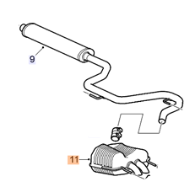

Per Gustafsson
Product Manager
Supply Chain Management

