MANUAL FOR BOOKING ON WWW.DANX.COM



CONTENTS
LOGIN AND CREDENTIALS 3
BOOK SHIPMENTS 4
ORDERS AND LABEL 5
TRACE 6

LOGIN AND CREDENTIALS

- Go to www.danx.com
- Go to My Danx
- Type in your username and password.
USERNAME: HPL_(country code. SE/FI/NO/DK)
PASSWORD: [alias/Dealer number]

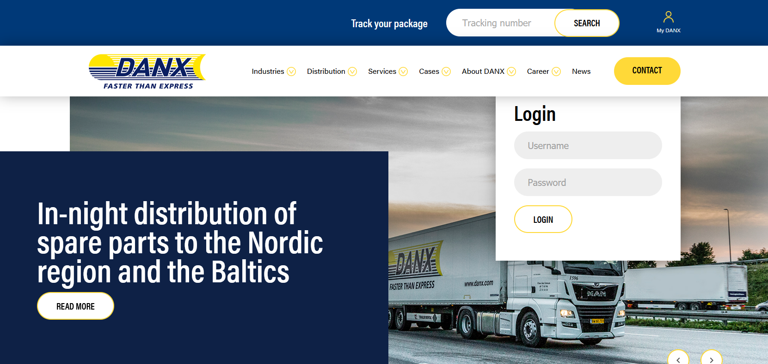

BOOK SHIPMENTS

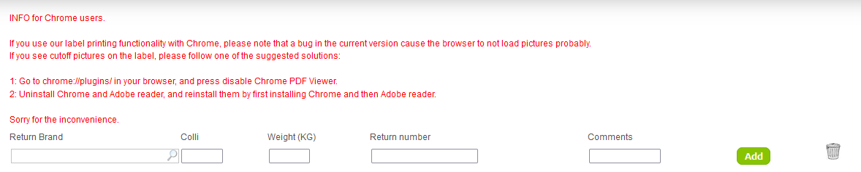
- Click magnifier and choose Brand, Add amount of collies and weight. The weight (kg) is a mandatory field. Comments are voluntary. Empty colli is 1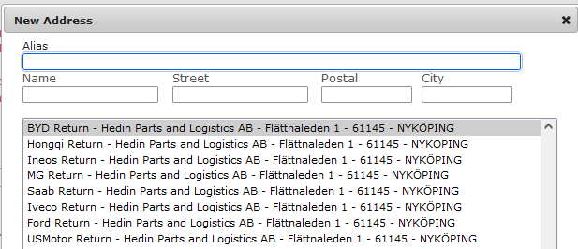
- When finished, click the Add button.
- Now the parcel is added. You now have three possibilities:
Add more parcels by filling in new info in the empty fields and click the Add button.
Edit already made booking by clicking on the Edit button.
Delete bookings by clicking the Trashcan symbol.
Send booking by clicking on the Send button.
- When clicking the Send button, the booking is made and the label(s) will pop up, please attach label(s) to the shipment(s).

ORDERS AND LABEL

- Under ORDERS you can see the orders placed the latest 24 hours. There are two functions here that can be used:
Reprint the label by clicking the Printer symbol. Alternatively Print all at the bottom of the list.
Delete the entire shipment from our systems in case of an error. This ONLY works until we have handled the shipment physically.
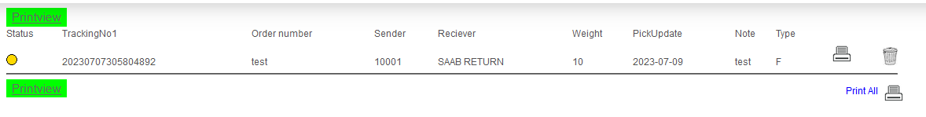
- This is how the label will look like:
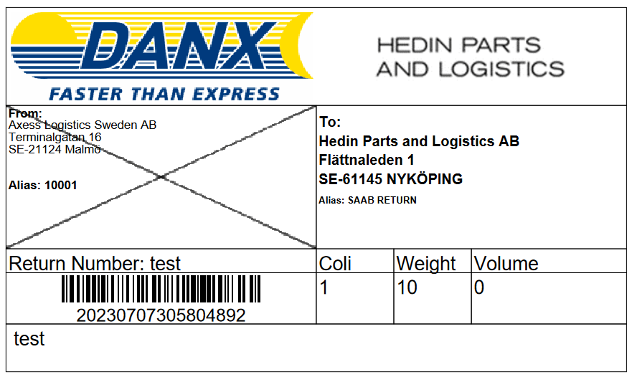

TRACE

The trace function gives you access to all the shipments from the last 30 days. You can filter on the following values:
Creation date
Trackingnumber/barcode
Return/Claim number
Pickup Address
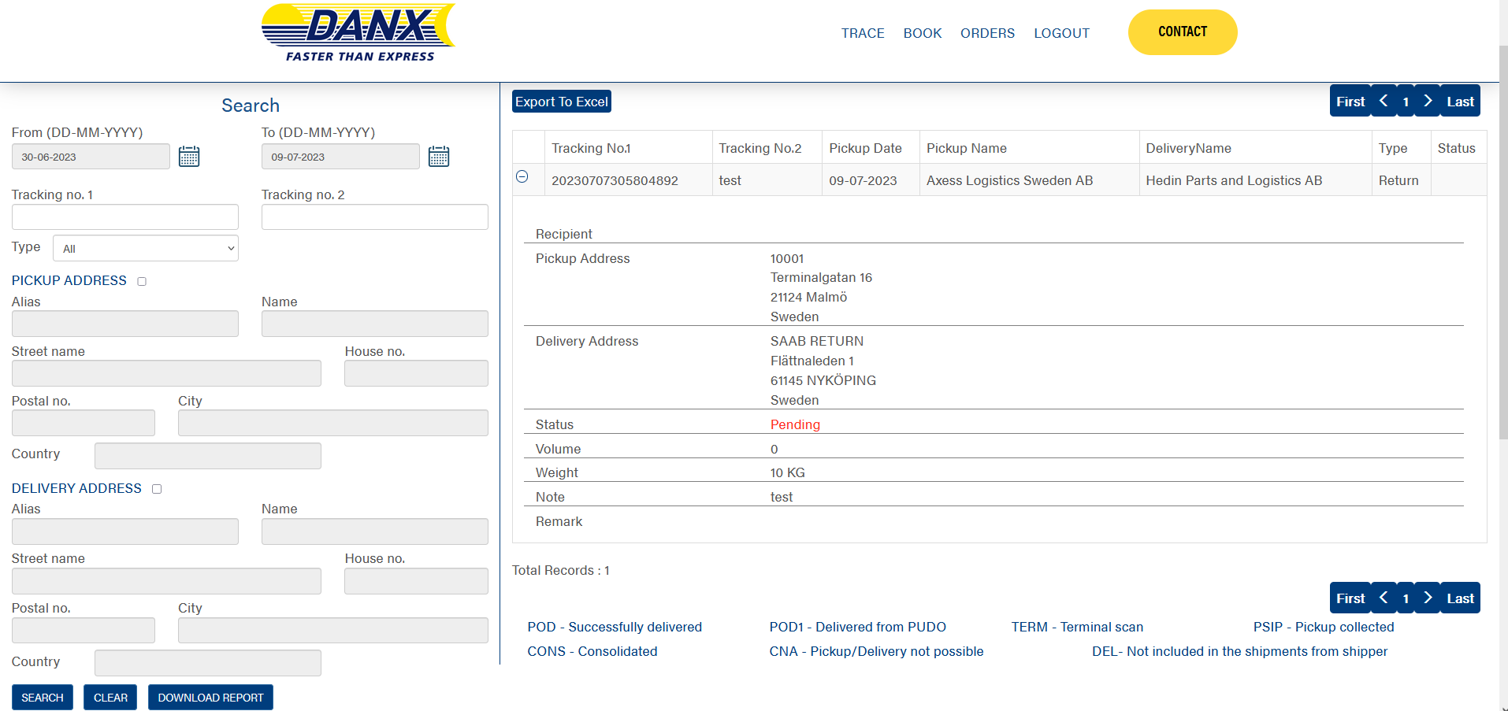
When the result is shown click on the shipment you want to view details on. It shows the following information:
Pickup date | Pickup address | Pickup city | Volume
Delivery name | Delivery address | Status | Weight
Trackingnumber/Barcode | Detailed status history | Recipient | Pickup name
Return/Claim number | Notes | Status

If the information is needed outside the system you can use the Export to Excel button to get a file saved to your PC’s desktop.

